Cranial Nerves
Number | Name | Function | Location
I | Olfactory Nerve | Smell | 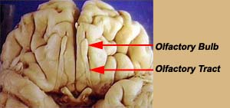
II | Optic Nerve | Vision | 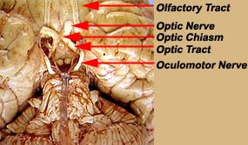
III | Oculomotor Nerve | Eye movement; pupil constriction | 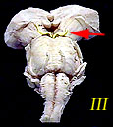
IV | Trochlear Nerve | Eye movement | 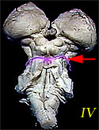
V | Trigeminal Nerve | Somatosensory information (touch, pain) from the face and head; muscles for chewing. | 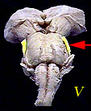
VI | Abducens Nerve | Eye movement | 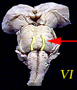
VII | Facial Nerve | Taste (anterior 2/3 of tongue); somatosensory information from ear; controls muscles used in facial expression. | 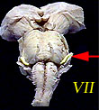
VIII | Vestibulocochlear Nerve | Hearing; balance | 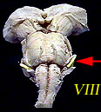
IX | Glossopharyngeal Nerve | Taste (posterior 1/3 of tongue); Somatosensory information from tongue, tonsil, pharynx; controls some muscles used in swallowing. | 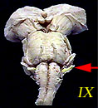
X | Vagus Nerve | Sensory, motor and autonomic functions of viscera (glands, digestion, heart rate) | 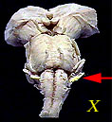
XI | Spinal Accessory Nerve | Controls muscles used in head movement. | 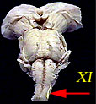
XII | Hypoglossal Nerve | Controls muscles of tongue | 