Crime Scene Search Methods

Link Method | Method is not a geometric pattern or easily definable.  There is no set pattern. The method requires the investigator to be able to form logical links between crime scene activity and the likely places additional evidence could be found at the scene as a result. | Method seeking to find associations between evidence. Investigators evaluate the scene and then proceed through the area in a systematic and logical fashion. Based on the notion that one type of evidence leads to another. Works with large and small, indoor and outdoor crime scenes.
Line (Strip) Method |  | Used on large, outdoor crime scenes. Members of the search team are arranged at regular intervals, usually arm’s length, and then proceed to search along straight lines.
Grid Method | 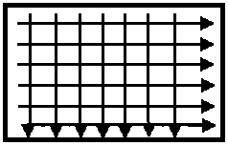 | Used on large, outdoor crime scenes. Searchers follow the first line pattern and search in the same manner as the line method. Once the first line pattern is complete, searchers realign on the other line pattern.
Zone Method | 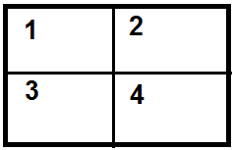 | Used on crime scenes that are comprised of readily definable zones, such as in houses or buildings. Teams are assigned small zones for searching, and then other appropriate searching methods are employed in each zone.
Spiral Method (Inward or Outward) | 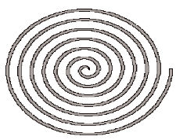 | Used on crime scenes with no physical barriers, such as with open water, etc. Can either begin at critical point of crime scene (outward spiral) or the outer-edge of the crime scene (inward spiral).
Wheel or Ray Method | 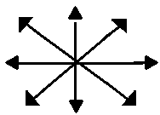 | Used on small, circular crime scenes. Investigators start from a critical point and travel outward along many straight lines from this point.

