Forensic Science Course Academic Calendar
2021-2022
Jennings Senior High School
Instructor: Marty Warren Room: S118 and Lab

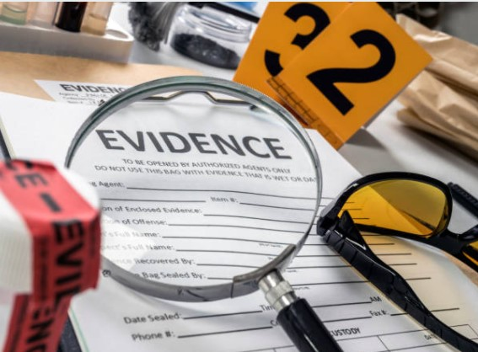

Weeks | 1st Semester Units | Weeks | 2nd Semester Units
August 23 to  September 3 | Introduction  - Forensic Science History  - Frye and Daubert  - Forensic Labs  - Forensic Experts  - Forensic Careers | January 4 to January 24 | Toxicology—Drugs, Poisons and Alcohol  - Presumptive and confirmatory tests  - Techniques, procedures, and instrumentation of a toxicology lab
September 7 to September 24 | Crime Scene  - Working a Crime Scene  - Types of Evidence  - Evidence collection and chain of custody  - Warrants, rights and amendments | January 25 to  Feb 22 | DNA  - Structure  - Typing--PCR, STR, mtDNA, y-chromosomal  - CODIS
September 27 to October 8 | Trace or Physical Evidence  - Hair--structure, microscopic examination, human vs animal  - Fiber--source and differences  - Glass--refractive index, density, fracture patterns | Feb 23 to March 17 | Blood Evidence  - Blood detection  - Blood pattern analysis
October 11 to October 29 | Fingerprints and Biometrics  - History  - Types of prints  - Minutia  - Lifting techniques  - NGI | March  28 to April 14 | Anthropology and Odontology  - Identification of major bones  - Determination of age, height, sex, and race  Forensic Art (optional)  Facial Reconstruction
November  1 to November 23 | Pathology  - Anatomy  - Autopsy—Manner, cause, and mechanism of death  - Time of Death  - Coroner vs Medical Examiner | April 19 to May 6 | Entomology (optional)  - Human decomposition  - Insect activity and PMI
November 29 to Dec13 | Criminology (optional)  - Profiling  - Victimology | May 9 to May 20 | Questioned Documents and  Digital Forensics (optional)
Dec 14 to 17 | First Semester Final Exam | May 23 to 25 | SLU Common Final Exam

