http://www.slu.edu/1818

FRSC 2600 Survey of Forensic Science
Jennings High School - Forensic Science H7022

Semester: FALL 2021 and SPRING 2022
Instructor: Marty Warren
Contact Information: Room S118
warrenm@jenningsk12.org
314-653-8100 Ext.7209
Office Hours: Monday, Wednesday, Thursday
3:00 PM – 4:00 PM or by appointment

Text/Resources Information:
TEXTBOOK: Forensic Science: An Introduction, Second Edition.
Richard Saferstein.
Pearson Prentice Hall, Upper Saddle River, New Jersey, 2011.
ISBN 10: 0-13-507433-9 ISBN 13: 978-0-13-507433-6

COVID Protocol: Students (and the instructor for this class) are required to wear a face mask at all times during class and laboratory exercises. Students are also required to keep a safe distance from each other and sit in assigned seats both in the classroom and in the laboratory.

1818 SLU Course Description:
Forensic science is the application of science to the law and involves various scientific disciplines. This course introduces the methodologies and applications used in forensic science, increases the understanding of the roles of various disciplines in crime investigation, and demonstrates the use of forensic science in actual cases. Problem solving and critical thinking skills will be utilized through the application of science concepts, illustrated through student research, projects, activities and class writings. Laboratory work that demonstrates the use of forensic science is an integral part of this course.

Additional Description
This one year (two semester) course is intended for students wishing to pursue a post-secondary degree in the forensic sciences including but not limited to accounting, anthropology, ballistics, biological sciences, chemistry, computer science, dental medicine, criminalistics, jurisprudence, law enforcement, medicine, medicolegal death investigation, microbiology, molecular genetics (DNA), nursing, pharmacology, psychology, physics, crime scene reconstruction, facial reconstruction, and toxicology. This course introduces the student to the scientific, legal, and historical perspective of crime scene evidence collection and analysis, and to methods for scientific research and development. This course encourages active learning by hands on experience from laboratory exposure to crime scene evidence collection. Through this, the student will gain a familiarity and appreciation of the application of forensic science laboratory techniques to the analysis of fingerprints, unknown chemicals, physical evidence, and biological clues.

Course Teaching GOALS:
- To introduce the various fields of forensic science, describing the forensic techniques, equipment and technology used in each.
- To present the roles that the various scientific disciplines (biology, chemistry, earth science, and physics) play in crime investigations
- To demonstrate the use of forensic science in actual cases.
- To introduce important past and present individuals in the field of forensic science.
- To design activities to improve problem solving and critical thinking skills.
- To educate the potential jury pool into one that is ready to serve with an understanding of the importance of forensic science

Course Learning OBJECTIVES*:
Students will be able to:
- compare and contrast the various fields of forensic science by showing an understanding of the techniques, equipment and technology used in each.
- differentiate and review the roles that the various scientific disciplines play in crime investigations.
- demonstrate the use of forensic science in actual cases through research, writings and various exams
- critique the importance of past and present individuals in the field of forensic science.
- perform activities that demonstrate the use of problem solving and/or critical thinking.
- justify and support a jury decision with the use of forensic evidence on a common final exam.

*All other common learning objectives for each unit/topic follows the course calendar in this syllabus. There will be one required writing project each semester and a common final with Saint Louis University. ALL students will take the final exam.

Method for Determining Final Grade
Exams 40%
Research and Writing Assessment 15%
Labs and Crime Investigations 20%
Quizzes and Do Now 5%
Final Exam | 20%
COURSE RECOMMENDATIONS: It is strongly advised that you use your time wisely and discipline yourself to read, study, and complete your assignments on time. Review your notes on a DAILY basis for about 30 to 45 minutes a day. DO NOT wait until the day PRIOR to the quiz/exam, as this will ultimately lead to your demise. It is not a good idea to rewrite your notes on the day BEFORE the exam/quiz/practicum. You should be reading everything over, and you should have a grasp on the material by that time. I don’t “give” grades- YOU earn them!

It is also advised that you should keep a 2” to 3” three ring binder with your notes, handouts, lab exercises, etc. You will need to refer to this information during the course, especially when processing a potential crime scene. Keep a log of your quiz, exam, lab, and practicum points handy so that you know how many points you have at any given time, and what you need to “shoot” for.

NO MAKEUP QUIZZES, LABORATORY EXERCISES, REPORTS, PRACTICUMS, OR EXAMS WILL BE ALLOWED UNDER ANY CIRCUMSTANCES WITHOUT PRIOR CONSENT OF INSTRUCTOR. This is a college level course and you will be expected to meet or exceed these standards. This is in preparation for future college level coursework. You may make arrangements to take your exam, quiz, or turn in your laboratory report PRIOR to your absence. Laboratory exercises and crime scene evaluations may NOT be made up in advance. PLEASE PLAN ACCORDINGLY. NO EXCEPTIONS!!!

SLU Grading Information: Unless otherwise presented in this section, Saint Louis University has reviewed and approved the above course grading scale to be used by the instructor for the transcripted Saint Louis University college grade. Saint Louis University’s undergraduate grading system follows a 0 - 4.000 grade point scale. Grades are assigned to the SLU transcript as follows:

Grade | Grade Scale | Percent | Interpretation
A | 4.000 | 93-100 | High achievement and intellectual initiative
A- | 3.700 | 90-92.9
B+ | 3.300 | 87-89.9 | Above average, approaching high achievement
B | 3.000 | 83-86.9 | Above average achievement
B- | 2.700 | 80-82.9
C+ | 2.300 | 77-79.9 | Midway between B and C
C | 2.000 | 73-76.9 | Average achievement
C- | 1.700 | 70-72.9
D | 1.000 | 60-69.9 | Inferior but passing achievement
F | 0 | <60 | Failure
Note on SLU undergraduate Cumulative GPA: The grade earned through the 1818 Advanced College Credit Program are considered Saint Louis University grades and will become part of the student’s undergraduate GPA if the student enrolls are Saint Louis University as a full time student.

Overall View of the Course Curriculum—a more detailed one follows.

First Semester | Second Semester
Introduction | Toxicology
Crime Scene | DNA
Trace or Physical Evidence | Blood and Blood Stain Pattern Analysis
Fingerprints and Biometrics | Anthropology and Odontology
Pathology | Forensic Art (Optional)
Criminology (Optional) | Forensic Entomology (Optional)
 | Questioned Documents and Digital Forensics (Optional)
The writing assessments are: Fall Semester: True Crime Case Study Research Paper Part I. Spring Semester: True Crime Case Study Research Paper Part II and Write a Detective Story using the Five Elements of Crime Novels. The story MUST include three major topics of study from EACH semester. Students may also create a 15 to 30 minute film/video “episode” of their story to present in class. A common final exam will be given at the end of the second semester.

Classroom Units of Study and Common Final Exam Objectives with Saint Louis University Additional objectives for each unit will be determined by instructor and listed within the class power points.

STUDENTS MUST BE ABLE TO:
Introduction
- Relate important advances in forensic science over time
- Demonstrate the importance of Frye and Daubert as it pertains to evidence
- Identify and describe the work of the various labs associated with a criminal investigation
- Describe how an expert witness is determined and how an expert witness shows effectiveness
- Justify the importance of having the means, motive, and opportunity in a criminal investigation.
- Compare/contrast physical evidence, giving an example of the different types

Crime Scene
- Describe the responsibilities of each member of the investigative team
- Specify the workings of a search warrant
- State the 4th and 5th amendments as it applied to criminal investigations
- Interpret one’s Miranda Rights
- Determine how evidence is collected and chain of custody is maintained
- Describe individual and class characteristics of various types of evidence

Trace Evidence
- Identify different types of trace evidence
- Indicate the differences between animal and human hair
- Describe the structure of human hair
- Compare differences in human hair
- Compare the types of DNA typing that can be accomplished with or without a root
- Compare similarities and differences in fiber types
- Determine glass type from density and/or refractive index

Fingerprints and other Biometrics
- Sequence the historical use of fingerprinting
- Determine the type of fingerprint (loops, arches, or whorls) from various surfaces
- Identify minutia within a fingerprint
- Identify ways to lift prints using various methods
- Explain the work of NGI (next generation identification), including AFIT

Pathology
- Compare a medical examiner with a coroner
- Describe the process and instruments of an autopsy
- Explain the terms manner, cause, and mechanism of death with examples
- Illustrate the differences between rigor, livor, and algor mortis with what can be determined from each.

Criminology (Optional)
- Understand the meaning of the term criminology and how it differs from forensic science.
- Explain how behavior contributes to crime, and list the rofessionals associated with criminal profiling.
- Understand the meaning of victimization, types of victimization, and signs of victimization.

Toxicology
- Describe the presumptive and confirmatory tests for drugs
- Assess a poison, its effects on the body, its toxicity and forensic means of identification
- Summarize the work of a toxicology lab
- Identify instruments used in a toxicology lab and describe their uses
- Describe the importance of toxicology to a criminal investigation

DNA
- Describe the structure of DNA
- Summarize the PCR method
- Interpret STR results from various test
- Compare and contrast nuclear DNA with mitochondrial DNA
- Summarize the work of CODIS

Blood Evidence/Blood Stain Pattern Analysis
- Describe testing methods for determining if a substance is blood
- Compare and contrast animal and human blood
- Determine the angle of impact, point of convergence, area of intersect
- Draw conclusions based on blood spatter pattern(s)

Anthropology and Odontology
- List the major large bones of the body that are most useful in forensic science and rank their importance
- Describe the role of an anthropologist in a criminal investigation
Determine sex, age, race, and height from a set of bones
- Explain how forensic odontologists identify human skeletal remains.
- Identify two different types of forensic examinations that forensic odontologists are asked to perform.
- Compare and analyze various sets of bite marks.

Forensic Art
- Explain Composite Imaging: Preparation of a sketch of an unknown subject from information obtained during an interview of a witness or victim.
- Describe the process of Facial Reconstruction: Preparation of a facial image of an unidentified deceased for the purpose of identification. These forensic images could be a three dimensional or two dimensional post mortem reconstructions.
- Explain the process of Age or Image Enhancement: These are images of age progressions, age regressions or image enhancements of subjects.

Forensic Entomology
- Describe the role of an entomologist in a criminal investigation
- Sequence insect infestation on a decaying body and describe its significance to time of death
- Explain the progression of human decomposition

Questioned Documents (optional)
- Describe the role of a document examiner to a criminal investigation
- Explain how handwriting analysis can link a person to a crime
- Determine how ink analysis is done and its importance to an investigation
- Evaluate the role of a forensic linguist to a criminal investigation

To Be Developed and Accomplished in Any Unit:
Discuss and evaluate the contributions of forensic experts in various fields
Research high profile cases, the main evidence involved, and the forensic work that was accomplished. Students will write conclusions based on scientific evidence within forensic science.

Information Essential to Student Success in SLU Course:

Academic Integrity Syllabus Statement--Academic integrity is honest, truthful and responsible conduct in all academic endeavors. The mission of Saint Louis University is "the pursuit of truth for the greater glory of God and for the service of humanity." Accordingly, all acts of falsehood demean and compromise the corporate endeavors of teaching, research, health care, and community service via which SLU embodies its mission. The University strives to prepare students for lives of personal and professional integrity, and therefore regards all breaches of academic integrity as matters of serious concern.

The governing University-level Academic Integrity Policy was adopted in Spring 2015 and can be accessed on the Provost's Office website.

Additionally, each SLU College, School, and Center has adopted its own academic integrity policies, available on their respective websites. A summary of Violations of Academic Integrity for the Department of Arts and Sciences follows:

1. Falsification entails misrepresentations of fact for academic gain.

2. Plagiarism involves the representation of someone else’s thoughts, words, and/or data as if they were one’s own or “self-plagiarism” which is the use of material prepared for one class and submitted to another without proper citation and without the permission of the instructor.

3. Cheating involves the use of unauthorized assistance to gain an advantage over others.
4. Sabotage entails disrupting or seeking to prevent the academic pursuits of others.

5. Collusion involves unauthorized collaboration with another person or persons for the purpose of giving or gaining an academic advantage in such activities as completion of assignments or examinations without explicit permission of the instructor.
6. Concealment entails failing to call to the attention of a faculty member or administrator violations of academic integrity that an academic unit requires be reported.

Any clear violation of academic integrity will be met with appropriate sanctions. Possible sanctions for violation of academic integrity may include, but are not limited to, assignment of a failing grade in a course, disciplinary probation, suspension, and dismissal from the University. Students should review the entire document as provided at the link below.

The full text may be read at:
https://www.slu.edu/academics/graduate/university-wide_academic_integrity_policy_final_6-26-15.pdf
SLU Disability Services Academic Accommodations--Students with a documented disability who wish to request academic accommodations must contact Disability Services to discuss accommodation requests and eligibility requirements. Once successfully registered, the student also must notify the course instructor that they wish to access accommodations in the course.
Please contact Disability Services, located within the Student Success Center, at Disability_services@slu.edu or 314.977.3484 to schedule an appointment. Confidentiality will be observed in all inquiries. Once approved, information about the student’s eligibility for academic accommodations will be shared with course instructors via email from Disability Services and viewed within Banner via the instructor’s course roster.

Note: Students who do not have a documented disability but who think they may have one are encouraged to contact to Disability Services.

SLU Student Success Center: In recognition that people learn in a variety of ways and that learning is influenced by multiple factors (e.g., prior experience, study skills, learning disability), resources to support student success are available on campus. The Student Success Center, a one-stop shop, which assists students with academic and career related services, is located in the Busch Student Center (Suite, 331) and the School of Nursing (Suite, 114). Students who think they might benefit from these resources can find out more about:
- Course-level support (e.g., faculty member, departmental resources, etc.) by asking your course instructor.
- University-level support (e.g., tutoring services, university writing services, disability services, academic coaching, career services, and/or facets of curriculum planning) by visiting the Student Success Center or by going to www.slu.edu/success.

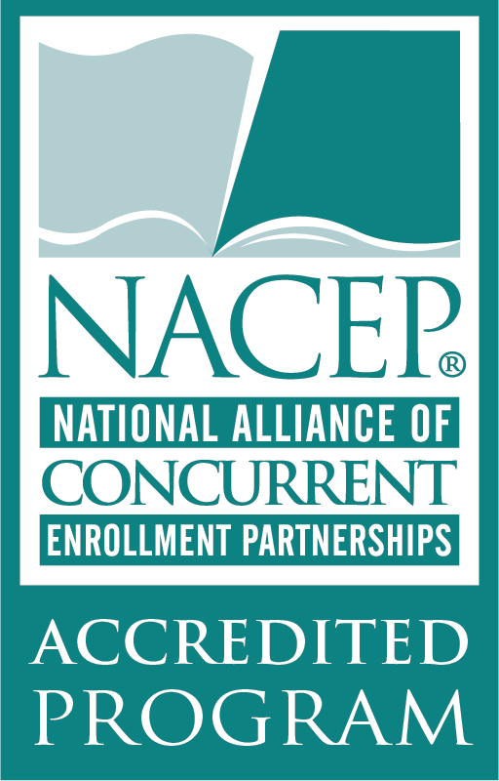
Saint Louis University Accreditation: As an institution, Saint Louis University is fully accredited by the Higher Learning Commission (HLC). SLU has been continuously accredited since 1916.
Additionally, the 1818 Advanced College Credit Program is a founding and fully accredited institution of the National Alliance of Concurrent Enrollment Partnerships (NACEP) and, complies with both the Missouri Department of Higher Education’s Dual Credit Policy (MDHE), Illinois Board of Higher Education (IBHE) Dual Credit Task Force, Ohio College Credit Plus, Iowa Senior Plus, and State of Hawaii Dual Credit Policy.

Forensic Science Course Academic Calendar
2021-2022
Jennings Senior High School
Instructor: Marty Warren Room: S118 and Lab

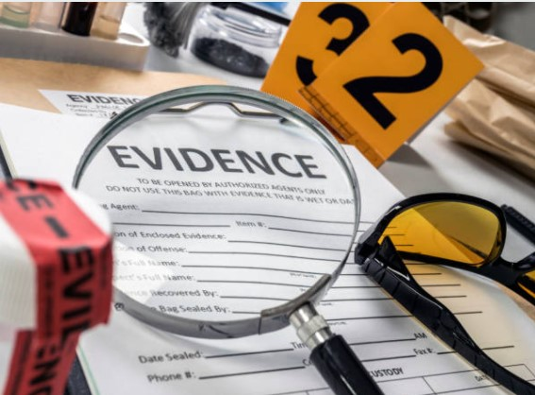

Weeks | 1st Semester Units | Weeks | 2nd Semester Units
August 23 to  September 3 | Introduction  - Forensic Science History  - Frye and Daubert  - Forensic Labs  - Forensic Experts  - Forensic Careers | January 4 to January 24 | Toxicology—Drugs, Poisons and Alcohol  - Presumptive and confirmatory tests  - Techniques, procedures, and instrumentation of a toxicology lab
September 7 to September 24 | Crime Scene  - Working a Crime Scene  - Types of Evidence  - Evidence collection and chain of custody  - Warrants, rights and amendments | January 25 to  Feb 22 | DNA  - Structure  - Typing--PCR, STR, mtDNA, y-chromosomal  - CODIS
September 27 to October 8 | Trace or Physical Evidence  - Hair--structure, microscopic examination, human vs animal  - Fiber--source and differences  - Glass--refractive index, density, fracture patterns | Feb 23 to March 17 | Blood Evidence  - Blood detection  - Blood pattern analysis
October 11 to October 29 | Fingerprints and Biometrics  - History  - Types of prints  - Minutia  - Lifting techniques  - NGI | March  28 to April 14 | Anthropology and Odontology  - Identification of major bones  - Determination of age, height, sex, and race  Forensic Art (optional)  Facial Reconstruction
November  1 to November 23 | Pathology  - Anatomy  - Autopsy—Manner, cause, and mechanism of death  - Time of Death  - Coroner vs Medical Examiner | April 19 to May 6 | Entomology (optional)  - Human decomposition  - Insect activity and PMI
November 29 to Dec13 | Criminology (optional)  - Profiling  - Victimology | May 9 to May 20 | Questioned Documents and  Digital Forensics (optional)
Dec 14 to 17 | First Semester Final Exam | May 23 to 25 | SLU Common Final Exam

