Introduction to Neuron Communication

Explain the way neurons communicate
All functions performed by the nervous system—from a simple motor reflex to more advanced functions like making a memory or a decision—require neurons to communicate with one another. While humans use words and body language to communicate, neurons use electrical and chemical signals. Just like a person in a committee, one neuron usually receives and synthesizes messages from multiple other neurons before “making the decision” to send the message on to other neurons.

Resting Membrane Potential
For the nervous system to function, neurons must be able to send and receive signals. These signals are possible because each neuron has a charged cellular membrane (a voltage difference between the inside and the outside), and the charge of this membrane can change in response to neurotransmitter molecules released from other neurons and environmental stimuli. To understand how neurons communicate, one must first understand the basis of the baseline or “resting” membrane charge.

Neuronal Charged Membranes
The lipid bilayer membrane that surrounds a neuron is impermeable to charged molecules or ions. To enter or exit the neuron, ions must pass through special proteins called ion channels that span the membrane. Ion channels have different configurations: open, closed, and inactive, as illustrated in Figure 1. Some ion channels need to be activated in order to open and allow ions to pass into or out of the cell. These ion channels are sensitive to the environment and can change their shape accordingly. Ion channels that change their structure in response to voltage changes are called voltage-gated ion channels. Voltage-gated ion channels regulate the relative concentrations of different ions inside and outside the cell. The difference in total charge between the inside and outside of the cell is called the membrane potential.
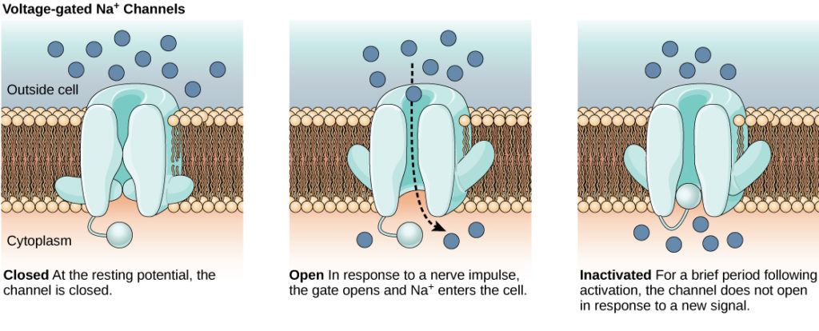

Resting Membrane Potential
A neuron at rest is negatively charged: the inside of a cell is approximately 70 millivolts more negative than the outside (−70 mV, note that this number varies by neuron type and by species). This voltage is called the resting membrane potential; it is caused by differences in the concentrations of ions inside and outside the cell. If the membrane were equally permeable to all ions, each type of ion would flow across the membrane and the system would reach equilibrium. Because ions cannot simply cross the membrane at will, there are different concentrations of several ions inside and outside the cell, as shown in Table 1.
Table 1. Ion Concentration Inside and Outside Neurons
Ion | Extracellular concentration (mM) | Intracellular concentration (mM) | Ratio outside/inside
Na⁺ | 145 | 12 | 12
K+ | 4 | 155 | 0.026
Cl⁻ | 120 | 4 | 30
Organic anions (A−) | — | 100
The resting membrane potential is a result of different concentrations inside and outside the cell. The difference in the number of positively charged potassium ions (K⁺) inside and outside the cell dominates the resting membrane potential (Figure 2).
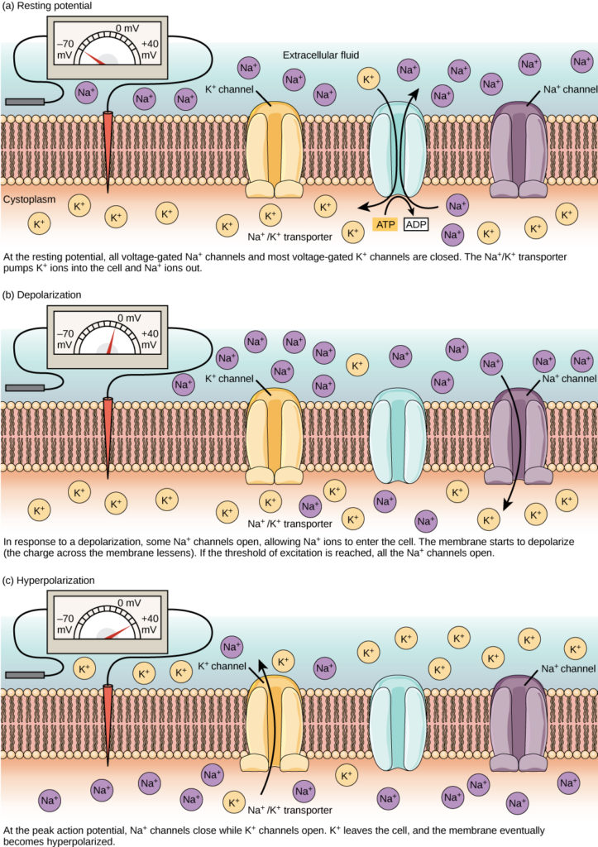
Figure 2. The (a) resting membrane potential is a result of different concentrations of Na⁺ and K⁺ ions inside and outside the cell. A nerve impulse causes Na⁺ to enter the cell, resulting in (b) depolarization. At the peak action potential, K⁺ channels open and the cell becomes (c) hyperpolarized.
When the membrane is at rest, K⁺ ions accumulate inside the cell due to a net movement with the concentration gradient. The negative resting membrane potential is created and maintained by increasing the concentration of cations outside the cell (in the extracellular fluid) relative to inside the cell (in the cytoplasm). The negative charge within the cell is created by the cell membrane being more permeable to potassium ion movement than sodium ion movement. In neurons, potassium ions are maintained at high concentrations within the cell while sodium ions are maintained at high concentrations outside of the cell. The cell possesses potassium and sodium leakage channels that allow the two cations to diffuse down their concentration gradient.
However, the neurons have far more potassium leakage channels than sodium leakage channels. Therefore, potassium diffuses out of the cell at a much faster rate than sodium leaks in. Because more cations are leaving the cell than are entering, this causes the interior of the cell to be negatively charged relative to the outside of the cell. The actions of the sodium potassium pump help to maintain the resting potential, once established. Recall that sodium potassium pumps brings two K⁺ ions into the cell while removing three Na⁺ ions per ATP consumed. As more cations are expelled from the cell than taken in, the inside of the cell remains negatively charged relative to the extracellular fluid. It should be noted that calcium ions (Cl–) tend to accumulate outside of the cell because they are repelled by negatively-charged proteins within the cytoplasm.

Action Potential
A neuron can receive input from other neurons and, if this input is strong enough, send the signal to downstream neurons. Transmission of a signal between neurons is generally carried by a chemical called a neurotransmitter. Transmission of a signal within a neuron (from dendrite to axon terminal) is carried by a brief reversal of the resting membrane potential called an action potential. When neurotransmitter molecules bind to receptors located on a neuron’s dendrites, ion channels open. At excitatory synapses, this opening allows positive ions to enter the neuron and results in depolarization of the membrane—a decrease in the difference in voltage between the inside and outside of the neuron. A stimulus from a sensory cell or another neuron depolarizes the target neuron to its threshold potential (−55 mV). Na⁺ channels in the axon hillock open, allowing positive ions to enter the cell (Figure 1).
Once the sodium channels open, the neuron completely depolarizes to a membrane potential of about +40 mV. Action potentials are considered an “all-or nothing” event, in that, once the threshold potential is reached, the neuron always completely depolarizes. Once depolarization is complete, the cell must now “reset” its membrane voltage back to the resting potential. To accomplish this, the Na⁺channels close and cannot be opened. This begins the neuron’s refractory period, in which it cannot produce another action potential because its sodium channels will not open. At the same time, voltage-gated K⁺ channels open, allowing K⁺ to leave the cell. As K⁺ ions leave the cell, the membrane potential once again becomes negative. The diffusion of K⁺ out of the cell actually hyperpolarizes the cell, in that the membrane potential becomes more negative than the cell’s normal resting potential. At this point, the sodium channels will return to their resting state, meaning they are ready to open again if the membrane potential again exceeds the threshold potential. Eventually the extra K⁺ ions diffuse out of the cell through the potassium leakage channels, bringing the cell from its hyperpolarized state, back to its resting membrane potential.

PRACTICE QUESTION
The formation of an action potential can be divided into five steps, which can be seen in Figure 1.
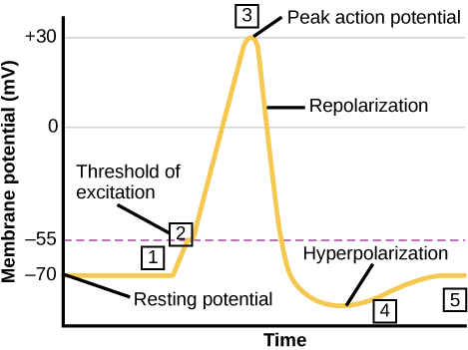
Figure 1. Action Potential
- A stimulus from a sensory cell or another neuron causes the target cell to depolarize toward the threshold potential.
- If the threshold of excitation is reached, all Na⁺ channels open and the membrane depolarizes.
- At the peak action potential, K⁺ channels open and K⁺ begins to leave the cell. At the same time, Na⁺ channels close.
- The membrane becomes hyperpolarized as K⁺ ions continue to leave the cell. The hyperpolarized membrane is in a refractory period and cannot fire.
- The K⁺ channels close and the Na⁺/K⁺ transporter restores the resting potential.
Potassium channel blockers, such as amiodarone and procainamide, which are used to treat abnormal electrical activity in the heart, called cardiac dysrhythmia, impede the movement of K⁺ through voltage-gated K⁺ channels. Which part of the action potential would you expect potassium channels to affect?
Show Answer
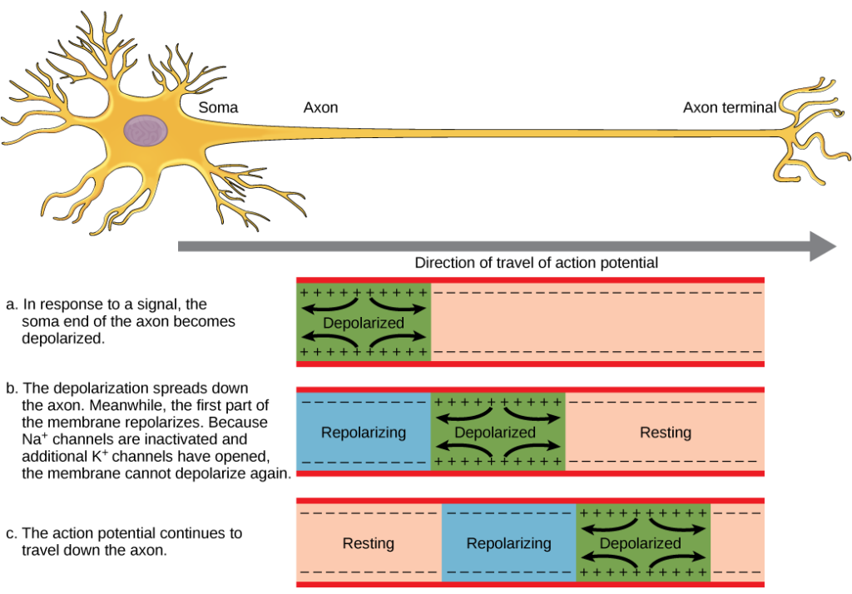
Figure 2. The action potential is conducted down the axon as the axon membrane depolarizes, then repolarizes.

Myelin and the Propagation of the Action Potential
For an action potential to communicate information to another neuron, it must travel along the axon and reach the axon terminals where it can initiate neurotransmitter release. The speed of conduction of an action potential along an axon is influenced by both the diameter of the axon and the axon’s resistance to current leak. Myelin acts as an insulator that prevents current from leaving the axon; this increases the speed of action potential conduction. In demyelinating diseases like multiple sclerosis, action potential conduction slows because current leaks from previously insulated axon areas.
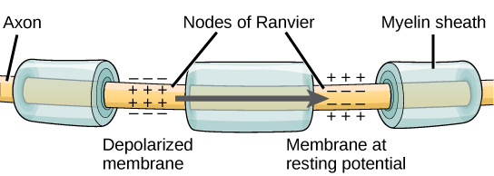
Figure 3. Nodes of Ranvier are gaps in myelin coverage along axons. Nodes contain voltage-gated K⁺ and Na⁺ channels. Action potentials travel down the axon by jumping from one node to the next.
The nodes of Ranvier, illustrated in Figure 3 are gaps in the myelin sheath along the axon. These unmyelinated spaces are about one micrometer long and contain voltage gated Na⁺ and K⁺ channels. Flow of ions through these channels, particularly the Na⁺ channels, regenerates the action potential over and over again along the axon. This ‘jumping’ of the action potential from one node to the next is called saltatory conduction. If nodes of Ranvier were not present along an axon, the action potential would propagate very slowly since Na⁺ and K⁺ channels would have to continuously regenerate action potentials at every point along the axon instead of at specific points. Nodes of Ranvier also save energy for the neuron since the channels only need to be present at the nodes and not along the entire axon.

Chemical and Electrical Synapses
The synapse or “gap” is the place where information is transmitted from one neuron to another. Synapses usually form between axon terminals and dendritic spines, but this is not universally true. There are also axon-to-axon, dendrite-to-dendrite, and axon-to-cell body synapses. The neuron transmitting the signal is called the presynaptic neuron, and the neuron receiving the signal is called the postsynaptic neuron. Note that these designations are relative to a particular synapse—most neurons are both presynaptic and postsynaptic. There are two types of synapses: chemical and electrical.

Chemical Synapse
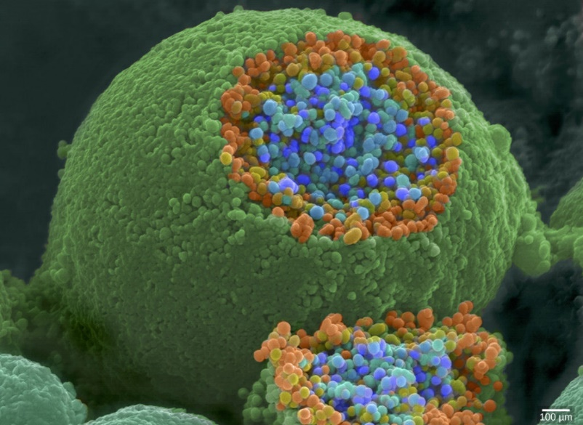
Figure 1. This pseudocolored image taken with a scanning electron microscope shows an axon terminal that was broken open to reveal synaptic vesicles (blue and orange) inside the neuron. (credit: modification of work by Tina Carvalho, NIH-NIGMS; scale-bar data from Matt Russell)
When an action potential reaches the axon terminal it depolarizes the membrane and opens voltage-gated Na⁺ channels. Na⁺ ions enter the cell, further depolarizing the presynaptic membrane. This depolarization causes voltage-gated Ca²⁺ channels to open. Calcium ions entering the cell initiate a signaling cascade that causes small membrane-bound vesicles, called synaptic vesicles, containing neurotransmitter molecules to fuse with the presynaptic membrane. Synaptic vesicles are shown in Figure 1, which is an image from a scanning electron microscope.
Fusion of a vesicle with the presynaptic membrane causes neurotransmitter to be released into the synaptic cleft, the extracellular space between the presynaptic and postsynaptic membranes, as illustrated in Figure 2. The neurotransmitter diffuses across the synaptic cleft and binds to receptor proteins on the postsynaptic membrane.
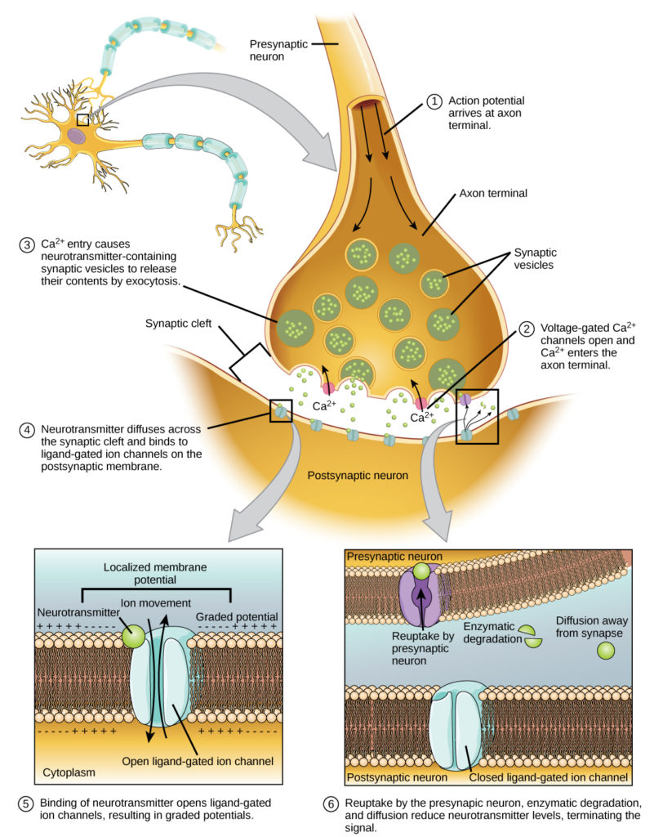
Figure 2. Communication at chemical synapses requires release of neurotransmitters. When the presynaptic membrane is depolarized, voltage-gated Ca2⁺ channels open and allow Ca2⁺ to enter the cell. The calcium entry causes synaptic vesicles to fuse with the membrane and release neurotransmitter molecules into the synaptic cleft. The neurotransmitter diffuses across the synaptic cleft and binds to ligand-gated ion channels in the postsynaptic membrane, resulting in a localized depolarization or hyperpolarization of the postsynaptic neuron.
The binding of a specific neurotransmitter causes particular ion channels, in this case ligand-gated channels, on the postsynaptic membrane to open. Neurotransmitters can either have excitatory or inhibitory effects on the postsynaptic membrane. There are several examples of well known neurotransmitters detailed in Table 1. For example, when acetylcholine is released at the synapse between a nerve and muscle (called the neuromuscular junction) by a presynaptic neuron, it causes postsynaptic Na⁺ channels to open. Na⁺ enters the postsynaptic cell and causes the postsynaptic membrane to depolarize. This depolarization is called an excitatory postsynaptic potential (EPSP) and makes the postsynaptic neuron more likely to fire an action potential. Release of neurotransmitter at inhibitory synapses causes inhibitory postsynaptic potentials (IPSPs), a hyperpolarization of the presynaptic membrane. For example, when the neurotransmitter GABA (gamma-aminobutyric acid) is released from a presynaptic neuron, it binds to and opens Cl– channels. Cl– ions enter the cell and hyperpolarizes the membrane, making the neuron less likely to fire an action potential.
Once neurotransmission has occurred, the neurotransmitter must be removed from the synaptic cleft so the postsynaptic membrane can “reset” and be ready to receive another signal. This can be accomplished in three ways: the neurotransmitter can diffuse away from the synaptic cleft, it can be degraded by enzymes in the synaptic cleft, or it can be recycled (sometimes called reuptake) by the presynaptic neuron. Several drugs act at this step of neurotransmission. For example, some drugs that are given to Alzheimer’s patients work by inhibiting acetylcholinesterase, the enzyme that degrades acetylcholine. This inhibition of the enzyme essentially increases neurotransmission at synapses that release acetylcholine. Once released, the acetylcholine stays in the cleft and can continually bind and unbind to postsynaptic receptors.
Table 1. Neurotransmitters
Neurotransmitter | Function | Location
Acetylcholine | muscle control, memory | CNS and/or PNS
Serotonin | intestinal movement, mood regulation, sleep | gut, CNS
Dopamine | voluntary muscle movements, cognition, reward pathways | hypothalamus
Norepinephrine | fight or flight response | adrenal medulla
GABA | inhibits CNS | brain
Glutamate | generally an excitatory neurotransmitter, memory | CNS, PNS

Electrical Synapse
While electrical synapses are fewer in number than chemical synapses, they are found in all nervous systems and play important and unique roles. The mode of neurotransmission in electrical synapses is quite different from that in chemical synapses. In an electrical synapse, the presynaptic and postsynaptic membranes are very close together and are actually physically connected by channel proteins forming gap junctions. Gap junctions allow current to pass directly from one cell to the next. In addition to the ions that carry this current, other molecules, such as ATP, can diffuse through the large gap junction pores.
There are key differences between chemical and electrical synapses. Because chemical synapses depend on the release of neurotransmitter molecules from synaptic vesicles to pass on their signal, there is an approximately one millisecond delay between when the axon potential reaches the presynaptic terminal and when the neurotransmitter leads to opening of postsynaptic ion channels. Additionally, this signaling is unidirectional. Signaling in electrical synapses, in contrast, is virtually instantaneous (which is important for synapses involved in key reflexes), and some electrical synapses are bidirectional. Electrical synapses are also more reliable as they are less likely to be blocked, and they are important for synchronizing the electrical activity of a group of neurons. For example, electrical synapses in the thalamus are thought to regulate slow-wave sleep, and disruption of these synapses can cause seizures.

Signal Summation
Sometimes a single EPSP is strong enough to induce an action potential in the postsynaptic neuron, but often multiple presynaptic inputs must create EPSPs around the same time for the postsynaptic neuron to be sufficiently depolarized to fire an action potential. This process is called summation and occurs at the axon hillock, as illustrated in Figure 1. Additionally, one neuron often has inputs from many presynaptic neurons—some excitatory and some inhibitory—so IPSPs can cancel out EPSPs and vice versa. It is the net change in postsynaptic membrane voltage that determines whether the postsynaptic cell has reached its threshold of excitation needed to fire an action potential. Together, synaptic summation and the threshold for excitation act as a filter so that random “noise” in the system is not transmitted as important information.

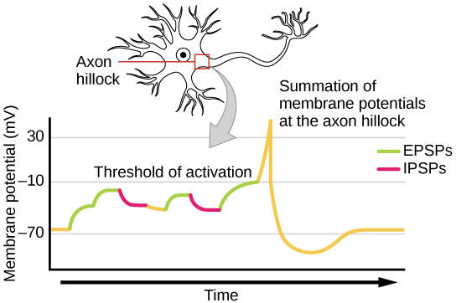

Synaptic Plasticity
Synapses are not static structures. They can be weakened or strengthened. They can be broken, and new synapses can be made. Synaptic plasticity allows for these changes, which are all needed for a functioning nervous system. In fact, synaptic plasticity is the basis of learning and memory. Two processes in particular, long-term potentiation (LTP) and long-term depression (LTD) are important forms of synaptic plasticity that occur in synapses in the hippocampus, a brain region that is involved in storing memories.

Long-term Potentiation (LTP)
Long-term potentiation (LTP) is a persistent strengthening of a synaptic connection. LTP is based on the Hebbian principle: cells that fire together wire together. There are various mechanisms, none fully understood, behind the synaptic strengthening seen with LTP. One known mechanism involves a type of postsynaptic glutamate receptor, called NMDA (N-Methyl-D-aspartate) receptors, shown in Figure 1.
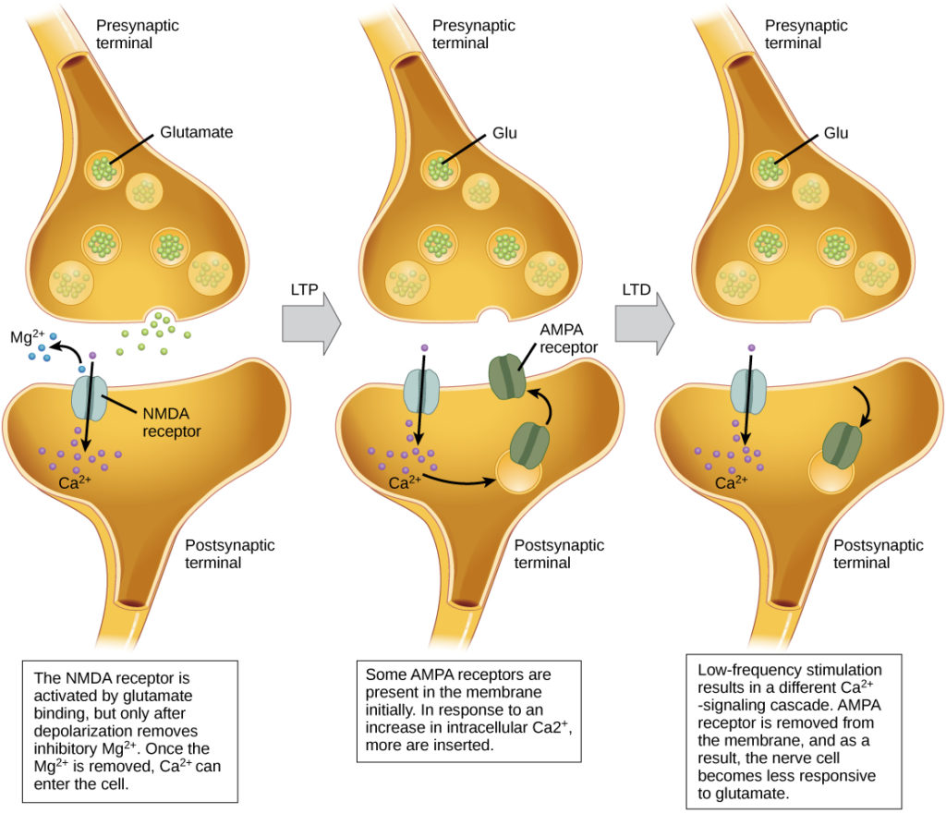
Figure 1. Calcium entry through postsynaptic NMDA receptors can initiate two different forms of synaptic plasticity: long-term potentiation (LTP) and long-term depression (LTD). LTP arises when a single synapse is repeatedly stimulated. This stimulation causes a calcium- and CaMKII-dependent cellular cascade, which results in the insertion of more AMPA receptors into the postsynaptic membrane. The next time glutamate is released from the presynaptic cell, it will bind to both NMDA and the newly inserted AMPA receptors, thus depolarizing the membrane more efficiently. LTD occurs when few glutamate molecules bind to NMDA receptors at a synapse (due to a low firing rate of the presynaptic neuron). The calcium that does flow through NMDA receptors initiates a different calcineurin and protein phosphatase 1-dependent cascade, which results in the endocytosis of AMPA receptors. This makes the postsynaptic neuron less responsive to glutamate released from the presynaptic neuron.
These receptors are normally blocked by magnesium ions; however, when the postsynaptic neuron is depolarized by multiple presynaptic inputs in quick succession (either from one neuron or multiple neurons), the magnesium ions are forced out allowing Ca ions to pass into the postsynaptic cell. Next, Ca²⁺ ions entering the cell initiate a signaling cascade that causes a different type of glutamate receptor, called AMPA (α-amino-3-hydroxy-5-methyl-4-isoxazolepropionic acid) receptors, to be inserted into the postsynaptic membrane, since activated AMPA receptors allow positive ions to enter the cell. So, the next time glutamate is released from the presynaptic membrane, it will have a larger excitatory effect (EPSP) on the postsynaptic cell because the binding of glutamate to these AMPA receptors will allow more positive ions into the cell. The insertion of additional AMPA receptors strengthens the synapse and means that the postsynaptic neuron is more likely to fire in response to presynaptic neurotransmitter release. Some drugs of abuse co-opt the LTP pathway, and this synaptic strengthening can lead to addiction.

Long-term Depression (LTD)
Long-term depression (LTD) is essentially the reverse of LTP: it is a long-term weakening of a synaptic connection. One mechanism known to cause LTD also involves AMPA receptors. In this situation, calcium that enters through NMDA receptors initiates a different signaling cascade, which results in the removal of AMPA receptors from the postsynaptic membrane, as illustrated in Figure 1. The decrease in AMPA receptors in the membrane makes the postsynaptic neuron less responsive to glutamate released from the presynaptic neuron. While it may seem counterintuitive, LTD may be just as important for learning and memory as LTP. The weakening and pruning of unused synapses allows for unimportant connections to be lost and makes the synapses that have undergone LTP that much stronger by comparison.

Components of the Central Nervous System
The central nervous system (CNS) is made up of the brain, a part of which is shown in Figure 1 and spinal cord and is covered with three layers of protective coverings called meninges (from the Greek word for membrane). The outermost layer is the dura mater(Latin for “hard mother”). As the Latin suggests, the primary function for this thick layer is to protect the brain and spinal cord. The dura mater also contains vein-like structures that carry blood from the brain back to the heart. The middle layer is the web-like arachnoid mater. The last layer is the pia mater (Latin for “soft mother”), which directly contacts and covers the brain and spinal cord like plastic wrap. The space between the arachnoid and pia maters is filled with cerebrospinal fluid (CSF). CSF is produced by a tissue called choroid plexus in fluid-filled compartments in the CNS called ventricles. The brain floats in CSF, which acts as a cushion and shock absorber and makes the brain neutrally buoyant. CSF also functions to circulate chemical substances throughout the brain and into the spinal cord.
The entire brain contains only about 8.5 tablespoons of CSF, but CSF is constantly produced in the ventricles. This creates a problem when a ventricle is blocked—the CSF builds up and creates swelling and the brain is pushed against the skull. This swelling condition is called hydrocephalus (“water head”) and can cause seizures, cognitive problems, and even death if a shunt is not inserted to remove the fluid and pressure.
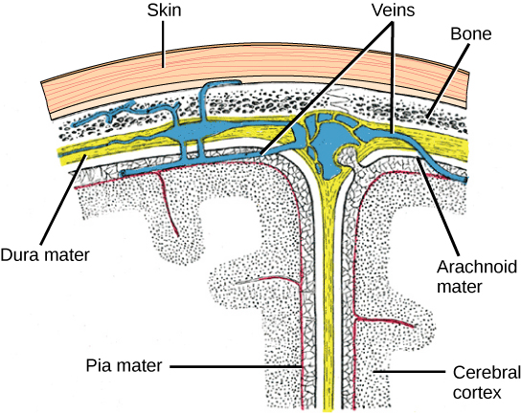

Brain
The brain is the part of the central nervous system that is contained in the cranial cavity of the skull. It includes the cerebral cortex, limbic system, basal ganglia, thalamus, hypothalamus, and cerebellum. There are three different ways that a brain can be sectioned in order to view internal structures: a sagittal section cuts the brain left to right, as shown in Figure 1b, a coronal section cuts the brain front to back, as shown in Figure 1a, and a horizontal section cuts the brain top to bottom.

Cerebral Cortex
The outermost part of the brain is a thick piece of nervous system tissue called the cerebral cortex, which is folded into hills called gyri (singular: gyrus) and valleys called sulci (singular: sulcus). The cortex is made up of two hemispheres—right and left—which are separated by a large sulcus. A thick fiber bundle called the corpus callosum (Latin: “tough body”) connects the two hemispheres and allows information to be passed from one side to the other. Although there are some brain functions that are localized more to one hemisphere than the other, the functions of the two hemispheres are largely redundant. In fact, sometimes (very rarely) an entire hemisphere is removed to treat severe epilepsy. While patients do suffer some deficits following the surgery, they can have surprisingly few problems, especially when the surgery is performed on children who have very immature nervous systems.
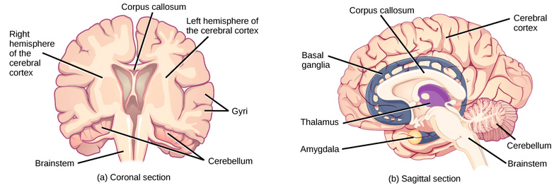
Figure 1. These illustrations show the (a) coronal and (b) sagittal sections of the human brain.
In other surgeries to treat severe epilepsy, the corpus callosum is cut instead of removing an entire hemisphere. This causes a condition called split-brain, which gives insights into unique functions of the two hemispheres. For example, when an object is presented to patients’ left visual field, they may be unable to verbally name the object (and may claim to not have seen an object at all). This is because the visual input from the left visual field crosses and enters the right hemisphere and cannot then signal to the speech center, which generally is found in the left side of the brain. Remarkably, if a split-brain patient is asked to pick up a specific object out of a group of objects with the left hand, the patient will be able to do so but will still be unable to vocally identify it.
Each cortical hemisphere contains regions called lobes that are involved in different functions. Scientists use various techniques to determine what brain areas are involved in different functions: they examine patients who have had injuries or diseases that affect specific areas and see how those areas are related to functional deficits. They also conduct animal studies where they stimulate brain areas and see if there are any behavioral changes. They use a technique called transmagnetic stimulation (TMS) to temporarily deactivate specific parts of the cortex using strong magnets placed outside the head; and they use functional magnetic resonance imaging (fMRI) to look at changes in oxygenated blood flow in particular brain regions that correlate with specific behavioral tasks. These techniques, and others, have given great insight into the functions of different brain regions but have also showed that any given brain area can be involved in more than one behavior or process, and any given behavior or process generally involves neurons in multiple brain areas. That being said, each hemisphere of the mammalian cerebral cortex can be broken down into four functionally and spatially defined lobes: frontal, parietal, temporal, and occipital. Figure 2 illustrates these four lobes of the human cerebral cortex.
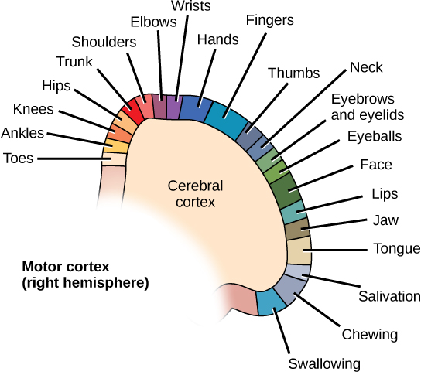
Figure 3. Different parts of the motor cortex control different muscle groups. Muscle groups that are neighbors in the body are generally controlled by neighboring regions of the motor cortex as well. For example, the neurons that control finger movement are near the neurons that control hand movement.
The frontal lobe is located at the front of the brain, over the eyes. This lobe contains the olfactory bulb, which processes smells. The frontal lobe also contains the motor cortex, which is important for planning and implementing movement. Areas within the motor cortex map to different muscle groups, and there is some organization to this map, as shown in Figure 3. For example, the neurons that control movement of the fingers are next to the neurons that control movement of the hand. Neurons in the frontal lobe also control cognitive functions like maintaining attention, speech, and decision-making. Studies of humans who have damaged their frontal lobes show that parts of this area are involved in personality, socialization, and assessing risk.
The parietal lobe is located at the top of the brain. Neurons in the parietal lobe are involved in speech and also reading. Two of the parietal lobe’s main functions are processing somatosensation—touch sensations like pressure, pain, heat, cold—and processing proprioception—the sense of how parts of the body are oriented in space. The parietal lobe contains a somatosensory map of the body similar to the motor cortex.
The occipital lobe is located at the back of the brain. It is primarily involved in vision—seeing, recognizing, and identifying the visual world.
The temporal lobe is located at the base of the brain by your ears and is primarily involved in processing and interpreting sounds. It also contains the hippocampus (Greek for “seahorse”)—a structure that processes memory formation. The hippocampus is illustrated in Figure 5. The role of the hippocampus in memory was partially determined by studying one famous epileptic patient, HM, who had both sides of his hippocampus removed in an attempt to cure his epilepsy. His seizures went away, but he could no longer form new memories (although he could remember some facts from before his surgery and could learn new motor tasks).

CEREBRAL CORTEX
Compared to other vertebrates, mammals have exceptionally large brains for their body size. An entire alligator’s brain, for example, would fill about one and a half teaspoons. This increase in brain to body size ratio is especially pronounced in apes, whales, and dolphins. While this increase in overall brain size doubtlessly played a role in the evolution of complex behaviors unique to mammals, it does not tell the whole story. Scientists have found a relationship between the relatively high surface area of the cortex and the intelligence and complex social behaviors exhibited by some mammals. This increased surface area is due, in part, to increased folding of the cortical sheet (more sulci and gyri). For example, a rat cortex is very smooth with very few sulci and gyri. Cat and sheep cortices have more sulci and gyri. Chimps, humans, and dolphins have even more.
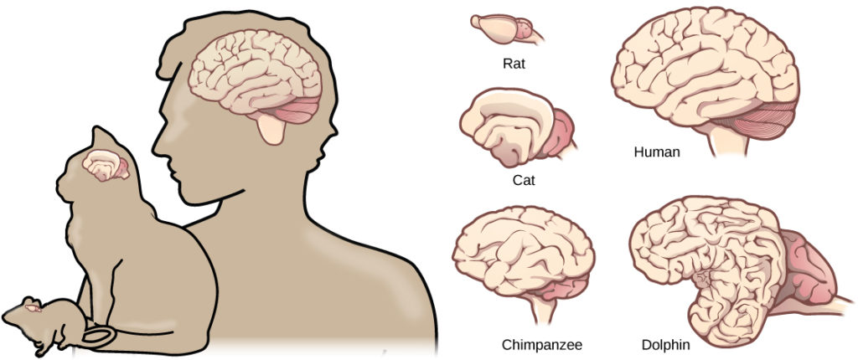
Figure 4. Mammals have larger brain-to-body ratios than other vertebrates. Within mammals, increased cortical folding and surface area is correlated with complex behavior.

Basal Ganglia
Interconnected brain areas called the basal ganglia (or basal nuclei), shown in Figure 1b, play important roles in movement control and posture. Damage to the basal ganglia, as in Parkinson’s disease, leads to motor impairments like a shuffling gait when walking. The basal ganglia also regulate motivation. For example, when a wasp sting led to bilateral basal ganglia damage in a 25-year-old businessman, he began to spend all his days in bed and showed no interest in anything or anybody. But when he was externally stimulated—as when someone asked to play a card game with him—he was able to function normally. Interestingly, he and other similar patients do not report feeling bored or frustrated by their state.

Thalamus
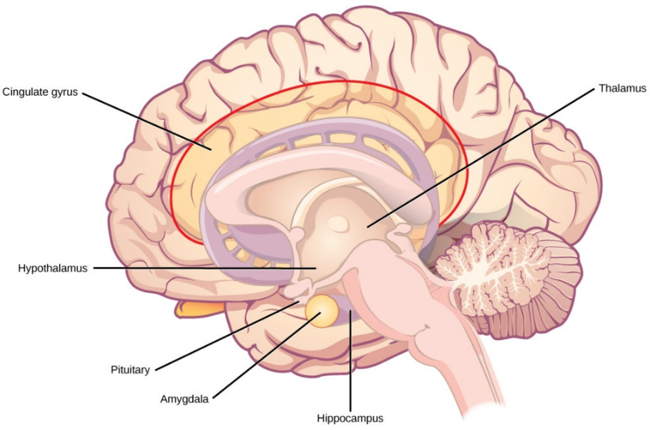
Figure 5. The limbic system regulates emotion and other behaviors. It includes parts of the cerebral cortex located near the center of the brain, including the cingulate gyrus and the hippocampus as well as the thalamus, hypothalamus and amygdala.
The thalamus (Greek for “inner chamber”), illustrated in Figure 5, acts as a gateway to and from the cortex. It receives sensory and motor inputs from the body and also receives feedback from the cortex. This feedback mechanism can modulate conscious awareness of sensory and motor inputs depending on the attention and arousal state of the animal. The thalamus helps regulate consciousness, arousal, and sleep states. A rare genetic disorder called fatal familial insomnia causes the degeneration of thalamic neurons and glia. This disorder prevents affected patients from being able to sleep, among other symptoms, and is eventually fatal.

Hypothalamus
Below the thalamus is the hypothalamus, shown in Figure 5. The hypothalamus controls the endocrine system by sending signals to the pituitary gland, a pea-sized endocrine gland that releases several different hormones that affect other glands as well as other cells. This relationship means that the hypothalamus regulates important behaviors that are controlled by these hormones. The hypothalamus is the body’s thermostat—it makes sure key functions like food and water intake, energy expenditure, and body temperature are kept at appropriate levels. Neurons within the hypothalamus also regulate circadian rhythms, sometimes called sleep cycles.

Limbic System
The limbic system is a connected set of structures that regulates emotion, as well as behaviors related to fear and motivation. It plays a role in memory formation and includes parts of the thalamus and hypothalamus as well as the hippocampus. One important structure within the limbic system is a temporal lobe structure called the amygdala (Greek for “almond”), illustrated in Figure 5. The two amygdala are important both for the sensation of fear and for recognizing fearful faces. The cingulate gyrus helps regulate emotions and pain.

Cerebellum
The cerebellum (Latin for “little brain”), shown in Figure 2, sits at the base of the brain on top of the brainstem. The cerebellum controls balance and aids in coordinating movement and learning new motor tasks.

Brainstem
The brainstem, illustrated in Figure 2, connects the rest of the brain with the spinal cord. It consists of the midbrain, medulla oblongata, and the pons. Motor and sensory neurons extend through the brainstem allowing for the relay of signals between the brain and spinal cord. Ascending neural pathways cross in this section of the brain allowing the left hemisphere of the cerebrum to control the right side of the body and vice versa. The brainstem coordinates motor control signals sent from the brain to the body. The brainstem controls several important functions of the body including alertness, arousal, breathing, blood pressure, digestion, heart rate, swallowing, walking, and sensory and motor information integration.

Spinal Cord
Connecting to the brainstem and extending down the body through the spinal column is the spinal cord. The spinal cord is a thick bundle of nerve tissue that carries information about the body to the brain and from the brain to the body. The spinal cord is contained within the bones of the vertebrate column but is able to communicate signals to and from the body through its connections with spinal nerves (part of the peripheral nervous system). A cross-section of the spinal cord looks like a white oval containing a gray butterfly-shape, as illustrated in Figure 1. Myelinated axons make up the “white matter” and neuron and glial cell bodies make up the “gray matter.” Gray matter is also composed of interneurons, which connect two neurons each located in different parts of the body. Axons and cell bodies in the dorsal (facing the back of the animal) spinal cord convey mostly sensory information from the body to the brain. Axons and cell bodies in the ventral (facing the front of the animal) spinal cord primarily transmit signals controlling movement from the brain to the body.
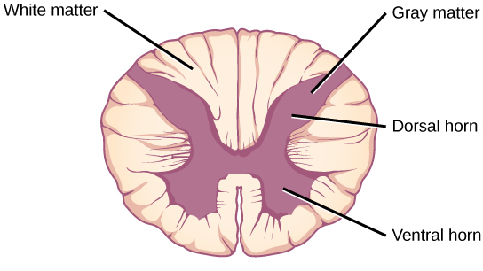
Figure 1. A cross-section of the spinal cord shows gray matter (containing cell bodies and interneurons) and white matter (containing axons).
The spinal cord also controls motor reflexes. These reflexes are quick, unconscious movements—like automatically removing a hand from a hot object. Reflexes are so fast because they involve local synaptic connections. For example, the knee reflex that a doctor tests during a routine physical is controlled by a single synapse between a sensory neuron and a motor neuron. While a reflex may only require the involvement of one or two synapses, synapses with interneurons in the spinal column transmit information to the brain to convey what happened (the knee jerked, or the hand was hot).
In the United States, there around 10,000 spinal cord injuries each year. Because the spinal cord is the information superhighway connecting the brain with the body, damage to the spinal cord can lead to paralysis. The extent of the paralysis depends on the location of the injury along the spinal cord and whether the spinal cord was completely severed. For example, if the spinal cord is damaged at the level of the neck, it can cause paralysis from the neck down, whereas damage to the spinal column further down may limit paralysis to the legs. Spinal cord injuries are notoriously difficult to treat because spinal nerves do not regenerate, although ongoing research suggests that stem cell transplants may be able to act as a bridge to reconnect severed nerves. Researchers are also looking at ways to prevent the inflammation that worsens nerve damage after injury. One such treatment is to pump the body with cold saline to induce hypothermia. This cooling can prevent swelling and other processes that are thought to worsen spinal cord injuries.

Autonomic Nervous System
In the autonomic nervous system, a preganglionic neuron of the CNS synapses with a postganglionic neuron of the PNS. The postganglionic neuron, in turn, acts on a target organ. Autonomic responses are mediated by the sympathetic and the parasympathetic systems, which are antagonistic to one another. The sympathetic system activates the “fight or flight” response, while the parasympathetic system activates the “rest and digest” response.
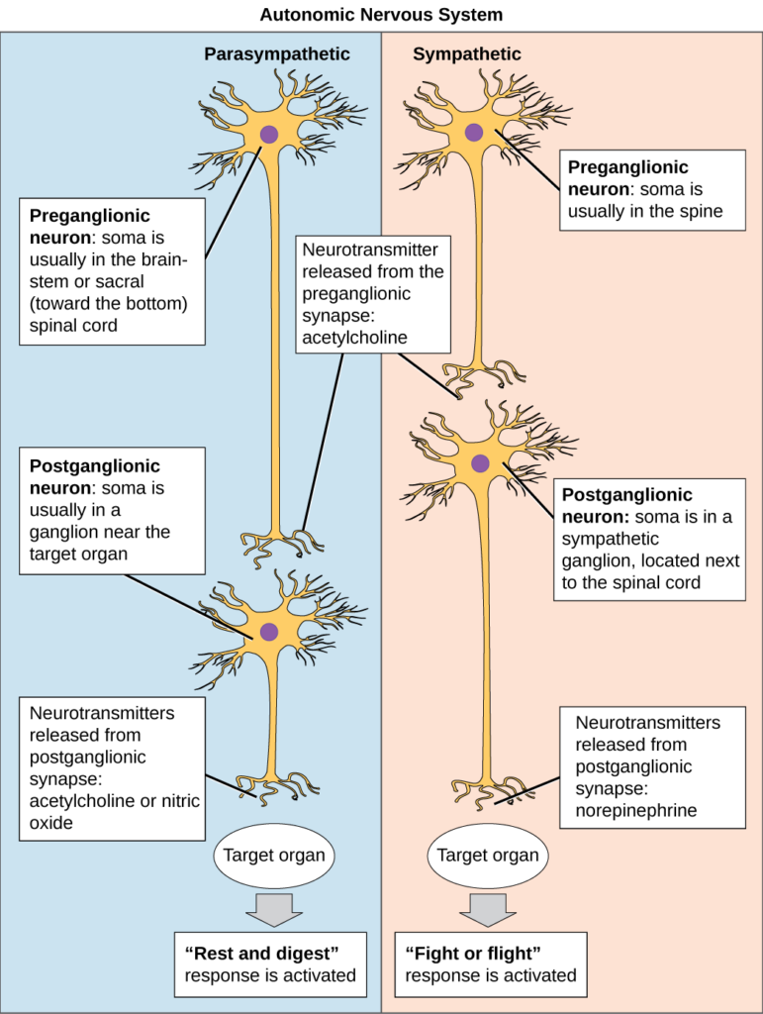
Figure 1. The sympathetic and parasympathetic systems
The autonomic nervous system serves as the relay between the CNS and the internal organs. It controls the lungs, the heart, smooth muscle, and exocrine and endocrine glands. The autonomic nervous system controls these organs largely without conscious control; it can continuously monitor the conditions of these different systems and implement changes as needed. Signaling to the target tissue usually involves two synapses: a preganglionic neuron (originating in the CNS) synapses to a neuron in a ganglion that, in turn, synapses on the target organ, as illustrated in Figure 1. There are two divisions of the autonomic nervous system that often have opposing effects: the sympathetic nervous system and the parasympathetic nervous system.

PRACTICE QUESTION
Which of the following statements is false?
- The parasympathetic pathway is responsible for resting the body, while the sympathetic pathway is responsible for preparing for an emergency.
- Most preganglionic neurons in the sympathetic pathway originate in the spinal cord.
- Slowing of the heartbeat is a parasympathetic response.
- Parasympathetic neurons are responsible for releasing norepinephrine on the target organ, while sympathetic neurons are responsible for releasing acetylcholine.
Show Answer

Sympathetic Nervous System
The sympathetic nervous system is responsible for the “fight or flight” response that occurs when an animal encounters a dangerous situation. One way to remember this is to think of the surprise a person feels when encountering a snake (“snake” and “sympathetic” both begin with “s”). Examples of functions controlled by the sympathetic nervous system include an accelerated heart rate and inhibited digestion. These functions help prepare an organism’s body for the physical strain required to escape a potentially dangerous situation or to fend off a predator.
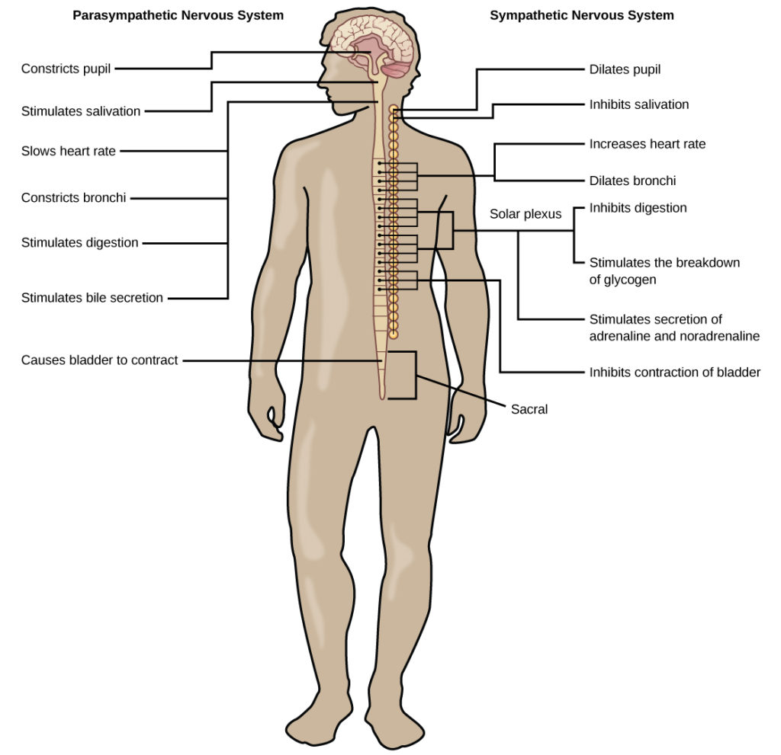
Figure 2. The sympathetic and parasympathetic nervous systems often have opposing effects on target organs.
Most preganglionic neurons in the sympathetic nervous system originate in the spinal cord, as illustrated in Figure 2. The axons of these neurons release acetylcholine on postganglionic neurons within sympathetic ganglia (the sympathetic ganglia form a chain that extends alongside the spinal cord). The acetylcholine activates the postganglionic neurons. Postganglionic neurons then release norepinephrine onto target organs. As anyone who has ever felt a rush before a big test, speech, or athletic event can attest, the effects of the sympathetic nervous system are quite pervasive. This is both because one preganglionic neuron synapses on multiple postganglionic neurons, amplifying the effect of the original synapse, and because the adrenal gland also releases norepinephrine (and the closely related hormone epinephrine) into the blood stream. The physiological effects of this norepinephrine release include dilating the trachea and bronchi (making it easier for the animal to breathe), increasing heart rate, and moving blood from the skin to the heart, muscles, and brain (so the animal can think and run). The strength and speed of the sympathetic response helps an organism avoid danger, and scientists have found evidence that it may also increase LTP—allowing the animal to remember the dangerous situation and avoid it in the future.

Parasympathetic Nervous System
While the sympathetic nervous system is activated in stressful situations, the parasympathetic nervous system allows an animal to “rest and digest.” The parasympathetic system’s functions conserve energy: slowing down the heart rate, reducing contractile forces of both cardiac and gastrointestinal muscle, and reducing conduction velocity of the sinoatrial node and atrioventricular node.
One way to remember this is to think that during a restful situation like a picnic, the parasympathetic nervous system is in control (“picnic” and “parasympathetic” both start with “p”). Parasympathetic preganglionic neurons have cell bodies located in the brainstem and in the sacral (toward the bottom) spinal cord, as shown in Figure 2. The axons of the preganglionic neurons release acetylcholine on the postganglionic neurons, which are generally located very near the target organs. Most postganglionic neurons release acetylcholine onto target organs, although some release nitric oxide. Acetylcholine acts on two types of receptors, the muscarinic and nicotinic cholinergic receptors. Most transmissions occur in two stages: When stimulated, the preganglionic neuron releases acetylcholine at the ganglion, which acts on nicotinic receptors of postganglionic neurons. The postganglionic neuron then releases acetylcholine to stimulate the muscarinic receptors of the target organ.
The parasympathetic nervous system resets organ function after the sympathetic nervous system is activated (the common adrenaline dump you feel after a “fight-or-flight” event). Effects of acetylcholine release on target organs include slowing of heart rate, lowered blood pressure, and stimulation of digestion.

Sensory-Somatic Nervous System
The sensory-somatic nervous system is made up of cranial and spinal nerves and contains both sensory and motor neurons. Sensory neurons transmit sensory information from the skin, skeletal muscle, and sensory organs to the CNS. Motor neurons transmit messages about desired movement from the CNS to the muscles to make them contract. Without its sensory-somatic nervous system, an animal would be unable to process any information about its environment (what it sees, feels, hears, and so on) and could not control motor movements. Unlike the autonomic nervous system, which has two synapses between the CNS and the target organ, sensory and motor neurons have only one synapse—one ending of the neuron is at the organ and the other directly contacts a CNS neuron. Acetylcholine is the main neurotransmitter released at these synapses.
Humans have 12 cranial nerves, nerves that emerge from or enter the skull (cranium), as opposed to the spinal nerves, which emerge from the vertebral column. Each cranial nerve is accorded a name, which are detailed in Figure 1.
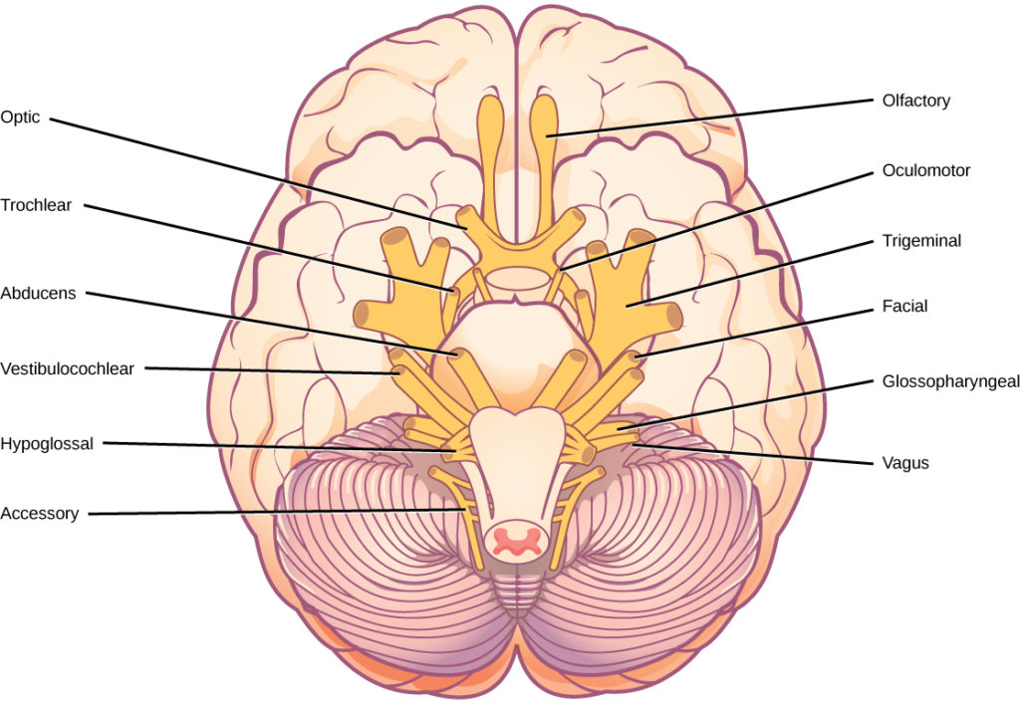
Figure 1. The human brain contains 12 cranial nerves that receive sensory input and control motor output for the head and neck.
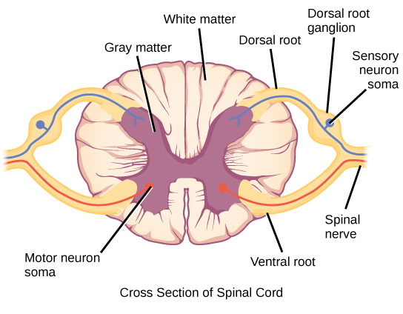
Figure 2. Spinal nerves contain both sensory and motor axons. The somas of sensory neurons are located in dorsal root ganglia. The somas of motor neurons are found in the ventral portion of the gray matter of the spinal cord.
Some cranial nerves transmit only sensory information. For example, the olfactory nerve transmits information about smells from the nose to the brainstem. Other cranial nerves transmit almost solely motor information. For example, the oculomotor nerve controls the opening and closing of the eyelid and some eye movements. Other cranial nerves contain a mix of sensory and motor fibers. For example, the glossopharyngeal nerve has a role in both taste (sensory) and swallowing (motor).
Spinal nerves transmit sensory and motor information between the spinal cord and the rest of the body. Each of the 31 spinal nerves (in humans) contains both sensory and motor axons. The sensory neuron cell bodies are grouped in structures called dorsal root ganglia and are shown in Figure 2.
Each sensory neuron has one projection—with a sensory receptor ending in skin, muscle, or sensory organs—and another that synapses with a neuron in the dorsal spinal cord. Motor neurons have cell bodies in the ventral gray matter of the spinal cord that project to muscle through the ventral root. These neurons are usually stimulated by interneurons within the spinal cord but are sometimes directly stimulated by sensory neurons.

Neurodegenerative Disorders
Neurodegenerative disorders are illnesses characterized by a loss of nervous system functioning that are usually caused by neuronal death. These diseases generally worsen over time as more and more neurons die. The symptoms of a particular neurodegenerative disease are related to where in the nervous system the death of neurons occurs. Spinocerebellar ataxia, for example, leads to neuronal death in the cerebellum. The death of these neurons causes problems in balance and walking. Neurodegenerative disorders include Huntington’s disease, amyotrophic lateral sclerosis, Alzheimer’s disease and other types of dementia disorders, and Parkinson’s disease. Here, Alzheimer’s and Parkinson’s disease will be discussed in more depth.

Alzheimer’s Disease
Alzheimer’s disease is the most common cause of dementia in the elderly. In 2012, an estimated 5.4 million Americans suffered from Alzheimer’s disease, and payments for their care are estimated at $200 billion. Roughly one in every eight people age 65 or older has the disease. Due to the aging of the baby-boomer generation, there are projected to be as many as 13 million Alzheimer’s patients in the United States in the year 2050.
Symptoms of Alzheimer’s disease include disruptive memory loss, confusion about time or place, difficulty planning or executing tasks, poor judgment, and personality changes. Problems smelling certain scents can also be indicative of Alzheimer’s disease and may serve as an early warning sign. Many of these symptoms are also common in people who are aging normally, so it is the severity and longevity of the symptoms that determine whether a person is suffering from Alzheimer’s.
Alzheimer’s disease was named for Alois Alzheimer, a German psychiatrist who published a report in 1911 about a woman who showed severe dementia symptoms. Along with his colleagues, he examined the woman’s brain following her death and reported the presence of abnormal clumps, which are now called amyloid plaques, along with tangled brain fibers called neurofibrillary tangles. Amyloid plaques, neurofibrillary tangles, and an overall shrinking of brain volume are commonly seen in the brains of Alzheimer’s patients. Loss of neurons in the hippocampus is especially severe in advanced Alzheimer’s patients. Figure 1 compares a normal brain to the brain of an Alzheimer’s patient. Many research groups are examining the causes of these hallmarks of the disease.
One form of the disease is usually caused by mutations in one of three known genes. This rare form of early onset Alzheimer’s disease affects fewer than five percent of patients with the disease and causes dementia beginning between the ages of 30 and 60. The more prevalent, late-onset form of the disease likely also has a genetic component. One particular gene, apolipoprotein E (APOE) has a variant (E4) that increases a carrier’s likelihood of getting the disease. Many other genes have been identified that might be involved in the pathology.
Visit this website for video links discussing genetics and Alzheimer’s disease.
Unfortunately, there is no cure for Alzheimer’s disease. Current treatments focus on managing the symptoms of the disease. Because decrease in the activity of cholinergic neurons (neurons that use the neurotransmitter acetylcholine) is common in Alzheimer’s disease, several drugs used to treat the disease work by increasing acetylcholine neurotransmission, often by inhibiting the enzyme that breaks down acetylcholine in the synaptic cleft. Other clinical interventions focus on behavioral therapies like psychotherapy, sensory therapy, and cognitive exercises. Since Alzheimer’s disease appears to hijack the normal aging process, research into prevention is prevalent. Smoking, obesity, and cardiovascular problems may be risk factors for the disease, so treatments for those may also help to prevent Alzheimer’s disease. Some studies have shown that people who remain intellectually active by playing games, reading, playing musical instruments, and being socially active in later life have a reduced risk of developing the disease.
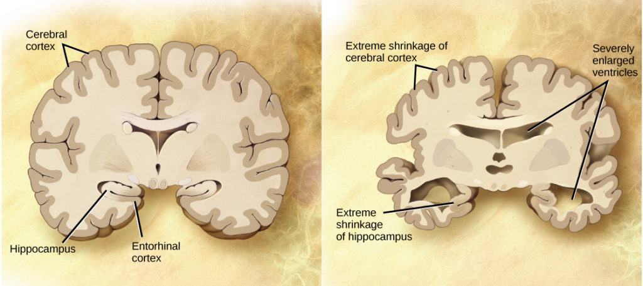
Figure 1. Compared to a normal brain (left), the brain from a patient with Alzheimer’s disease (right) shows a dramatic neurodegeneration, particularly within the ventricles and hippocampus. (credit: modification of work by “Garrando”/Wikimedia Commons based on original images by ADEAR: “Alzheimer’s Disease Education and Referral Center, a service of the National Institute on Aging”)

Parkinson’s Disease
Like Alzheimer’s disease, Parkinson’s disease is a neurodegenerative disease. It was first characterized by James Parkinson in 1817. Each year, 50,000-60,000 people in the United States are diagnosed with the disease. Parkinson’s disease causes the loss of dopamine neurons in the substantia nigra, a midbrain structure that regulates movement. Loss of these neurons causes many symptoms including tremor (shaking of fingers or a limb), slowed movement, speech changes, balance and posture problems, and rigid muscles. The combination of these symptoms often causes a characteristic slow hunched shuffling walk, illustrated in Figure 2. Patients with Parkinson’s disease can also exhibit psychological symptoms, such as dementia or emotional problems.
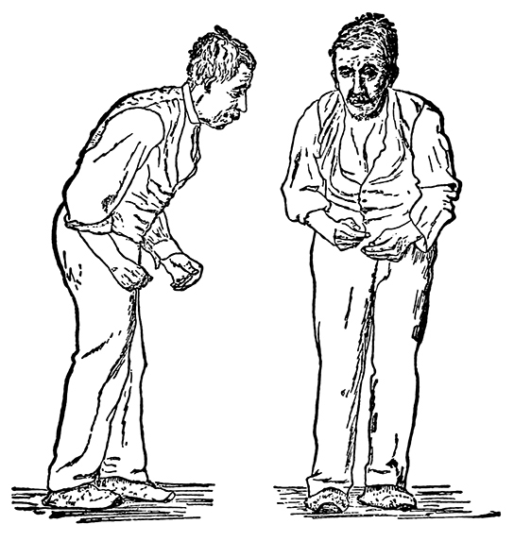
Figure 2. Parkinson’s patients often have a characteristic hunched walk.
Although some patients have a form of the disease known to be caused by a single mutation, for most patients the exact causes of Parkinson’s disease remain unknown: the disease likely results from a combination of genetic and environmental factors (similar to Alzheimer’s disease). Post-mortem analysis of brains from Parkinson’s patients shows the presence of Lewy bodies—abnormal protein clumps—in dopaminergic neurons. The prevalence of these Lewy bodies often correlates with the severity of the disease.
There is no cure for Parkinson’s disease, and treatment is focused on easing symptoms. One of the most commonly prescribed drugs for Parkinson’s is L-DOPA, which is a chemical that is converted into dopamine by neurons in the brain. This conversion increases the overall level of dopamine neurotransmission and can help compensate for the loss of dopaminergic neurons in the substantia nigra. Other drugs work by inhibiting the enzyme that breaks down dopamine.

Neurodevelopmental Disorders
Neurodevelopmental disorders occur when the development of the nervous system is disturbed. There are several different classes of neurodevelopmental disorders. Some, like Down Syndrome, cause intellectual deficits. Others specifically affect communication, learning, or the motor system. Some disorders like autism spectrum disorder and attention deficit/hyperactivity disorder have complex symptoms.

Autism
Autism spectrum disorder (ASD) is a neurodevelopmental disorder. Its severity differs from person to person. Estimates for the prevalence of the disorder have changed rapidly in the past few decades. Current estimates suggest that one in 88 children will develop the disorder. ASD is four times more prevalent in males than females.
A characteristic symptom of ASD is impaired social skills. Children with autism may have difficulty making and maintaining eye contact and reading social cues. They also may have problems feeling empathy for others. Other symptoms of ASD include repetitive motor behaviors (such as rocking back and forth), preoccupation with specific subjects, strict adherence to certain rituals, and unusual language use. Up to 30 percent of patients with ASD develop epilepsy, and patients with some forms of the disorder (like Fragile X) also have intellectual disability. Because it is a spectrum disorder, other ASD patients are very functional and have good-to-excellent language skills. Many of these patients do not feel that they suffer from a disorder and instead think that their brains just process information differently.
Except for some well-characterized, clearly genetic forms of autism (like Fragile X and Rett’s Syndrome), the causes of ASD are largely unknown. Variants of several genes correlate with the presence of ASD, but for any given patient, many different mutations in different genes may be required for the disease to develop. At a general level, ASD is thought to be a disease of “incorrect” wiring. Accordingly, brains of some ASD patients lack the same level of synaptic pruning that occurs in non-affected people. In the 1990s, a research paper linked autism to a common vaccine given to children. This paper was retracted when it was discovered that the author falsified data, and follow-up studies showed no connection between vaccines and autism.
Treatment for autism usually combines behavioral therapies and interventions, along with medications to treat other disorders common to people with autism (depression, anxiety, obsessive compulsive disorder). Although early interventions can help mitigate the effects of the disease, there is currently no cure for ASD.

Attention Deficit Hyperactivity Disorder (ADHD)
Approximately three to five percent of children and adults are affected by attention deficit/hyperactivity disorder (ADHD). Like ASD, ADHD is more prevalent in males than females. Symptoms of the disorder include inattention (lack of focus), executive functioning difficulties, impulsivity, and hyperactivity beyond what is characteristic of the normal developmental stage. Some patients do not have the hyperactive component of symptoms and are diagnosed with a subtype of ADHD: attention deficit disorder (ADD). Many people with ADHD also show comorbitity, in that they develop secondary disorders in addition to ADHD. Examples include depression or obsessive compulsive disorder (OCD). Figure 1 provides some statistics concerning comorbidity with ADHD.
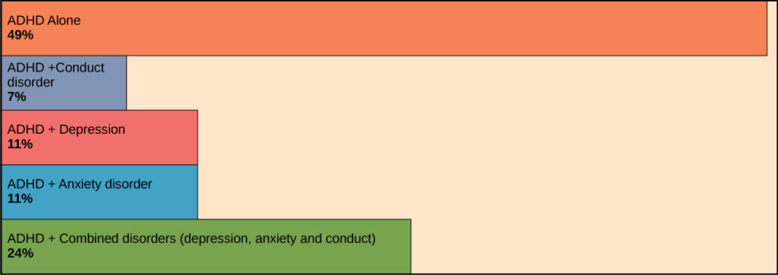
Figure 1. Many people with ADHD have one or more other neurological disorders. (credit “chart design and illustration”: modification of work by Leigh Coriale; credit “data”: Drs. Biederman and Faraone, Massachusetts General Hospital)
The cause of ADHD is unknown, although research points to a delay and dysfunction in the development of the prefrontal cortex and disturbances in neurotransmission. According to studies of twins, the disorder has a strong genetic component. There are several candidate genes that may contribute to the disorder, but no definitive links have been discovered. Environmental factors, including exposure to certain pesticides, may also contribute to the development of ADHD in some patients. Treatment for ADHD often involves behavioral therapies and the prescription of stimulant medications, which paradoxically cause a calming effect in these patients.

Mental Illnesses
Mental illnesses are nervous system disorders that result in problems with thinking, mood, or relating with other people. These disorders are severe enough to affect a person’s quality of life and often make it difficult for people to perform the routine tasks of daily living. Debilitating mental disorders plague approximately 12.5 million Americans (about 1 in 17 people) at an annual cost of more than $300 billion. There are several types of mental disorders including schizophrenia, major depression, bipolar disorder, anxiety disorders and phobias, post-traumatic stress disorders, and obsessive-compulsive disorder (OCD), among others. The American Psychiatric Association publishes the Diagnostic and Statistical Manual of Mental Disorders (or DSM), which describes the symptoms required for a patient to be diagnosed with a particular mental disorder. Each newly released version of the DSM contains different symptoms and classifications as scientists learn more about these disorders, their causes, and how they relate to each other. A more detailed discussion of two mental illnesses—schizophrenia and major depression—is given below.

Schizophrenia
Schizophrenia is a serious and often debilitating mental illness affecting one percent of people in the United States. Symptoms of the disease include the inability to differentiate between reality and imagination, inappropriate and unregulated emotional responses, difficulty thinking, and problems with social situations. People with schizophrenia can suffer from hallucinations and hear voices; they may also suffer from delusions. Patients also have so-called “negative” symptoms like a flattened emotional state, loss of pleasure, and loss of basic drives. Many schizophrenic patients are diagnosed in their late adolescence or early 20s.
The development of schizophrenia is thought to involve malfunctioning dopaminergic neurons and may also involve problems with glutamate signaling. Treatment for the disease usually requires antipsychotic medications that work by blocking dopamine receptors and decreasing dopamine neurotransmission in the brain. This decrease in dopamine can cause Parkinson’s disease-like symptoms in some patients. While some classes of antipsychotics can be quite effective at treating the disease, they are not a cure, and most patients must remain medicated for the rest of their lives.

Depression
Major depression affects approximately 6.7 percent of the adults in the United States each year and is one of the most common mental disorders. To be diagnosed with major depressive disorder, a person must have experienced a severely depressed mood lasting longer than two weeks along with other symptoms including a loss of enjoyment in activities that were previously enjoyed, changes in appetite and sleep schedules, difficulty concentrating, feelings of worthlessness, and suicidal thoughts.
The exact causes of major depression are unknown and likely include both genetic and environmental risk factors. Some research supports the “classic monoamine hypothesis,” which suggests that depression is caused by a decrease in norepinephrine and serotonin neurotransmission. One argument against this hypothesis is the fact that some antidepressant medications cause an increase in norepinephrine and serotonin release within a few hours of beginning treatment—but clinical results of these medications are not seen until weeks later. This has led to alternative hypotheses: for example, dopamine may also be decreased in depressed patients, or it may actually be an increase in norepinephrine and serotonin that causes the disease, and antidepressants force a feedback loop that decreases this release.
Treatments for depression include psychotherapy, electroconvulsive therapy, deep-brain stimulation, and prescription medications. There are several classes of antidepressant medications that work through different mechanisms. For example, monoamine oxidase inhibitors (MAO inhibitors) block the enzyme that degrades many neurotransmitters (including dopamine, serotonin, norepinephrine), resulting in increased neurotransmitter in the synaptic cleft. Selective serotonin reuptake inhibitors (SSRIs) block the reuptake of serotonin into the presynaptic neuron. This blockage results in an increase in serotonin in the synaptic cleft. Other types of drugs such as norepinephrine-dopamine reuptake inhibitors and norepinephrine-serotonin reuptake inhibitors are also used to treat depression.

Other Neurological Disorders
There are several other neurological disorders that cannot be easily placed in the above categories. These include chronic pain conditions, cancers of the nervous system, epilepsy disorders, and stroke. Epilepsy and stroke are discussed below.

Epilepsy
Estimates suggest that up to three percent of people in the United States will be diagnosed with epilepsy in their lifetime. While there are several different types of epilepsy, all are characterized by recurrent seizures. Epilepsy itself can be a symptom of a brain injury, disease, or other illness. For example, people who have intellectual disability or ASD can experience seizures, presumably because the developmental wiring malfunctions that caused their disorders also put them at risk for epilepsy. For many patients, however, the cause of their epilepsy is never identified and is likely to be a combination of genetic and environmental factors. Often, seizures can be controlled with anticonvulsant medications. However, for very severe cases, patients may undergo brain surgery to remove the brain area where seizures originate.

Stroke
A stroke results when blood fails to reach a portion of the brain for a long enough time to cause damage. Without the oxygen supplied by blood flow, neurons in this brain region die. This neuronal death can cause many different symptoms—depending on the brain area affected— including headache, muscle weakness or paralysis, speech disturbances, sensory problems, memory loss, and confusion. Stroke is often caused by blood clots and can also be caused by the bursting of a weak blood vessel. Strokes are extremely common and are the third most common cause of death in the United States. On average one person experiences a stroke every 40 seconds in the United States. Approximately 75 percent of strokes occur in people older than 65. Risk factors for stroke include high blood pressure, diabetes, high cholesterol, and a family history of stroke. Smoking doubles the risk of stroke. Because a stroke is a medical emergency, patients with symptoms of a stroke should immediately go to the emergency room, where they can receive drugs that will dissolve any clot that may have formed. These drugs will not work if the stroke was caused by a burst blood vessel or if the stroke occurred more than three hours before arriving at the hospital. Treatment following a stroke can include blood pressure medication (to prevent future strokes) and (sometimes intense) physical therapy.

