TERMS
Efferent | Afferent
Efferent neurons are motor neurons that carry neural impulses away from the central nervous systme and towards muscles to cause movement. | Afferent neurons are sensory neurons that carry nerve impulses from sensory stimuli towards the central nervous system and brain,

Prions | Prion Disease | Mad Cow Disease | Tay Sachs Disease
Prions are misfolded proteins with the ability to transmit their misfolded shape onto normal variants of the same protein. They characterize several fatal and transmissible neurodegenerative diseases in humans and many other animals.  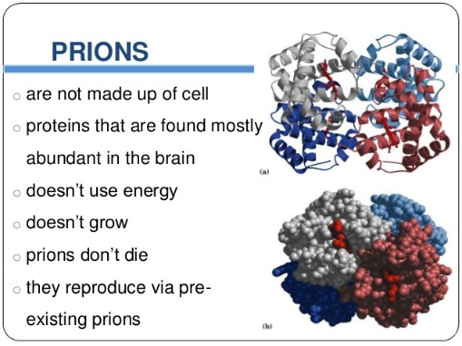 | A prion is a type of protein that can trigger normal proteins in the brain to fold abnormally. Prion diseases can affect both humans and animals and are sometimes spread to humans by infected meat products. The most common form of prion disease that affects humans is Creutzfeldt-Jakob disease (CJD).  Fewer than 1,000 US cases per year  Treatment can help, but this condition can't be cured  Requires a medical diagnosis  Lab tests or imaging always required  Chronic: can last for years or be lifelong  Creutzfeldt-Jakob disease may occur spontaneously, be inherited, or be transmitted by contact with infected tissue, such as during a transplant or from eating contaminated meat.  The condition causes personality changes, anxiety, depression, and memory loss, usually within a few months. Many people lapse into coma.  Because no effective treatment exists, the focus is on alleviating pain and relieving symptoms. | Mad cow disease, or bovine spongiform encephalopathy (BSE), is a disease that was first found in cattle. It's related to a disease in humans called variant Creutzfeldt-Jakob disease (vCJD). Both disorders are universally fatal brain diseases caused by a prion. | an inherited metabolic disorder in which certain lipids accumulate in the brain, causing spasticity and death in childhood.

Grey Matter | White Matter
Grey matter is distinguished from white matter in that it contains numerous cell bodies and relatively few myelinated axons. | White matter contains relatively few cell bodies and is composed chiefly of long-range myelinated axons. The color difference arises mainly from the whiteness of myelin.

Convolution: any of the numerous convex folds or ridges of the surface of the brain. Increases the surface area of the brain
