Ten Cranial Nerves and their Functions
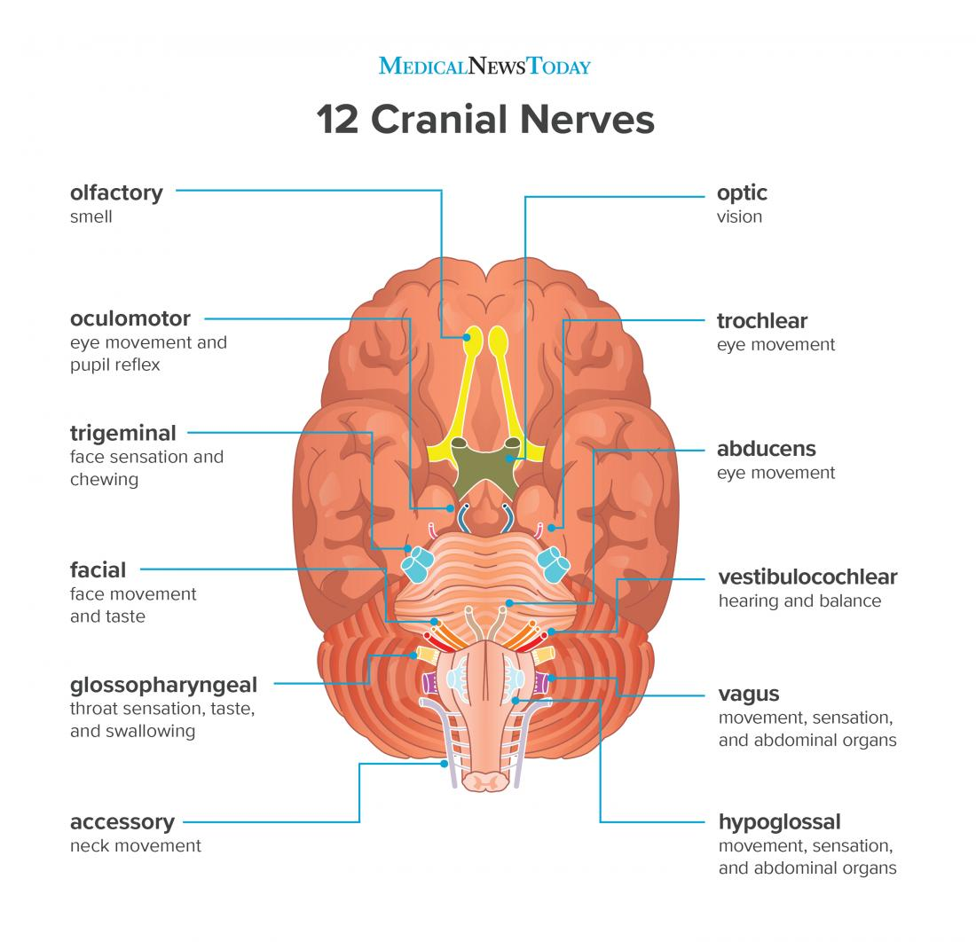

Ten Cranial Nerves and Function

Number | Name | Function
I
II
III
IV
V
VI
VII
VIII
IX
X
XI
XII

