Types of Glia
There are several different types of glia with different functions, two of which are shown in Figure 1. 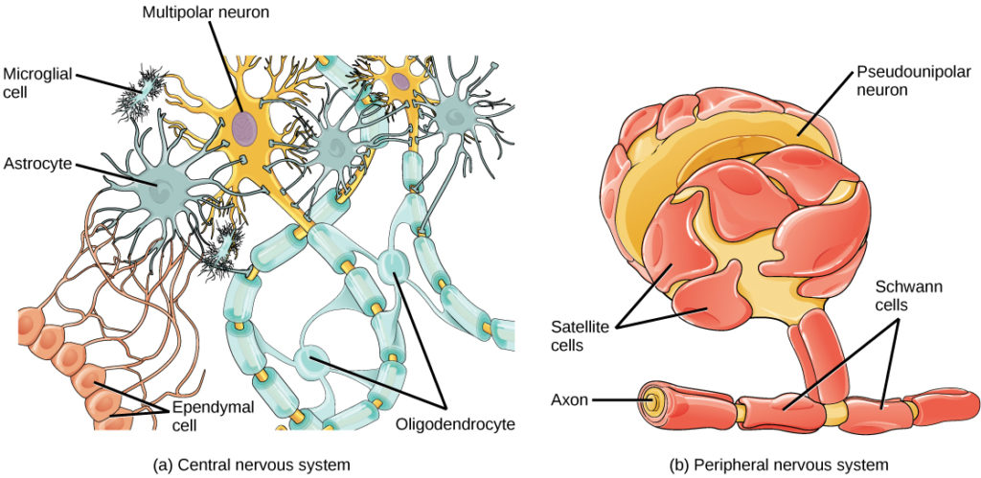

Figure 1. Glial cells support neurons and maintain their environment. Glial cells of the (a) central nervous system include oligodendrocytes, astrocytes, ependymal cells, and microglial cells. Oligodendrocytes form the myelin sheath around axons. Astrocytes provide nutrients to neurons, maintain their extracellular environment, and provide structural support. Microglia scavenge pathogens and dead cells. Ependymal cells produce cerebrospinal fluid that cushions the neurons. Glial cells of the (b) peripheral nervous system include Schwann cells, which form the myelin sheath, and satellite cells, which provide nutrients and structural support to neurons.
Astrocytes, shown in Figure 2a make contact with both capillaries and neurons in the CNS. They provide nutrients and other substances to neurons, regulate the concentrations of ions and chemicals in the extracellular fluid, and provide structural support for synapses. Astrocytes also form the blood-brain barrier—a structure that blocks entrance of toxic substances into the brain. Astrocytes, in particular, have been shown through calcium imaging experiments to become active in response to nerve activity, transmit calcium waves between astrocytes, and modulate the activity of surrounding synapses.
Satellite glia provide nutrients and structural support for neurons in the PNS. Microglia scavenge and degrade dead cells and protect the brain from invading microorganisms. Oligodendrocytes, shown in Figure 2b form myelin sheaths around axons in the CNS. One axon can be myelinated by several oligodendrocytes, and one oligodendrocyte can provide myelin for multiple neurons. This is distinctive from the PNS where a single Schwann cell provides myelin for only one axon as the entire Schwann cell surrounds the axon. Radial glia serve as scaffolds for developing neurons as they migrate to their end destinations. Ependymal cells line fluid-filled ventricles of the brain and the central canal of the spinal cord. They are involved in the production of cerebrospinal fluid, which serves as a cushion for the brain, moves the fluid between the spinal cord and the brain, and is a component of the choroid plexus.

